DOKUMENTACIJA

Gymster

Predmet: PHP 2

Ljubivoje Tomic 124/20

Contents

Uvod 5

Korisceni jezici I biblioteke 5

Opis funkcionalnosti 6

Template 6

Slike stranica 7

Baza podataka 12

Kodovi 12

Kontroleri 12

AdminController 12

BaseController 13

BlogController 14

ContactController 17

Controller 18

HomeController 18

UserController 19

Middlewares 20

NotAuthorized 20

CheckRole 21

Requests 21

StoreBlog 22

StoreComment 22

StoreMessage 23

StoreUser 24

UpdateBlog 25

Kernel 26

Models 27

Blog 27

Category 28

Comment 28

Image 29

User 29

Providers 30

AppServiceProvider 30

View/Components 31

Card 31

Config 31

App 32

CSS 37

Style.css 37

JS 48

Main.js 48

VIEWS 52

Fixed 53

adminFooter 53

adminHead 53

adminScripts 54

footer 55

head 57

nav 57

scripts 59

Layouts 60

adminLayout 60

Layout 60

Pages 60

Main 61

About 61

contact 61

Home 63

Join 67

Login 68

Blogs 69

Admin_add_blog 69

Admin_edit_blog 71

Blog 72

Single_blog 74

Admin 76

adminHome 76

Web.php 80

# Uvod

Gymster sajt sluzi za citanje blogove I razmenjivanje misljenja o tim blogovima putem komentara koje mogu da objavljuju samo clanovi sajta.Ukoliko bilo ko ima pitanje u vezi bilo cega moze se obratiti putem stranice za kontakt.

## Korisceni jezici I biblioteke

1)HTML

2)CSS

3)JS

4)BOOTSTRAP

5)JQUERY

6)PHP

7)LARAVEL

## Opis funkcionalnosti

Navigacioni meni prilagodjen za sve uredjaje.

Sekcija treneri je ispisana iz baze podataka.

Na blog stranici korisnik moze videte blogove I moze ih pretrazivati po njihovom nazivu(ukljucena I paginacija).

Klikom na naziv bloga otvara se novi prozor gde korisnik moze procitati blog I ostaviti svoj komentar(ukoliko je ulogovan).

Takodje korisnik moze obrisati svoj komentar.

Na stranici contact svi korisnici(I oni koji nisu ulogovani) mogu poslati poruku adminu.

Admin moze da menja I edituje blogove.Takodje ima pregled porukama, moze manipulisati svim korisnicima, menjati im status I role, a ima I pristup spisku aktivnosti.

Nakon sto korisnik unese kredencijale njegov profil ce biti napravljen I moci ce da se uloguje.

Ako korisnik ima status 2 to znaci da je on banovan I nece moci da se loginuje.

Ukoliko je prijavljeni korisnik admin moci ce da unosi nove blogove.

Sve crud operacije na admin panelu(osim dodavanja I editovanja blogova) su uradjene preko ajaxa.

## Template

Za svrhu ovog sajta preuzet je template:

<https://www.free-css.com/free-css-templates/page285/gymster>

## Slike stranica

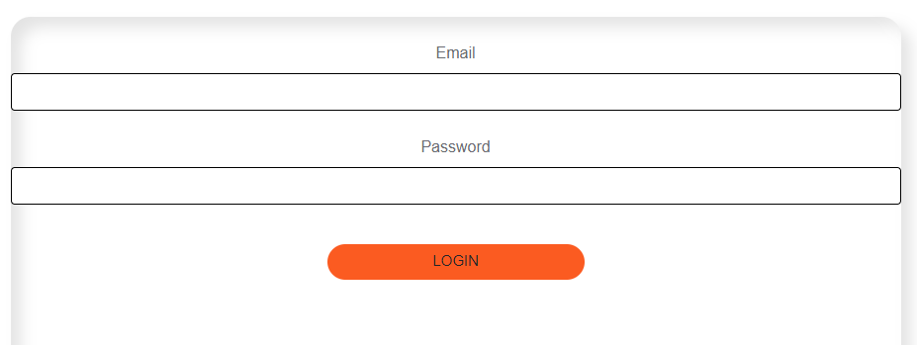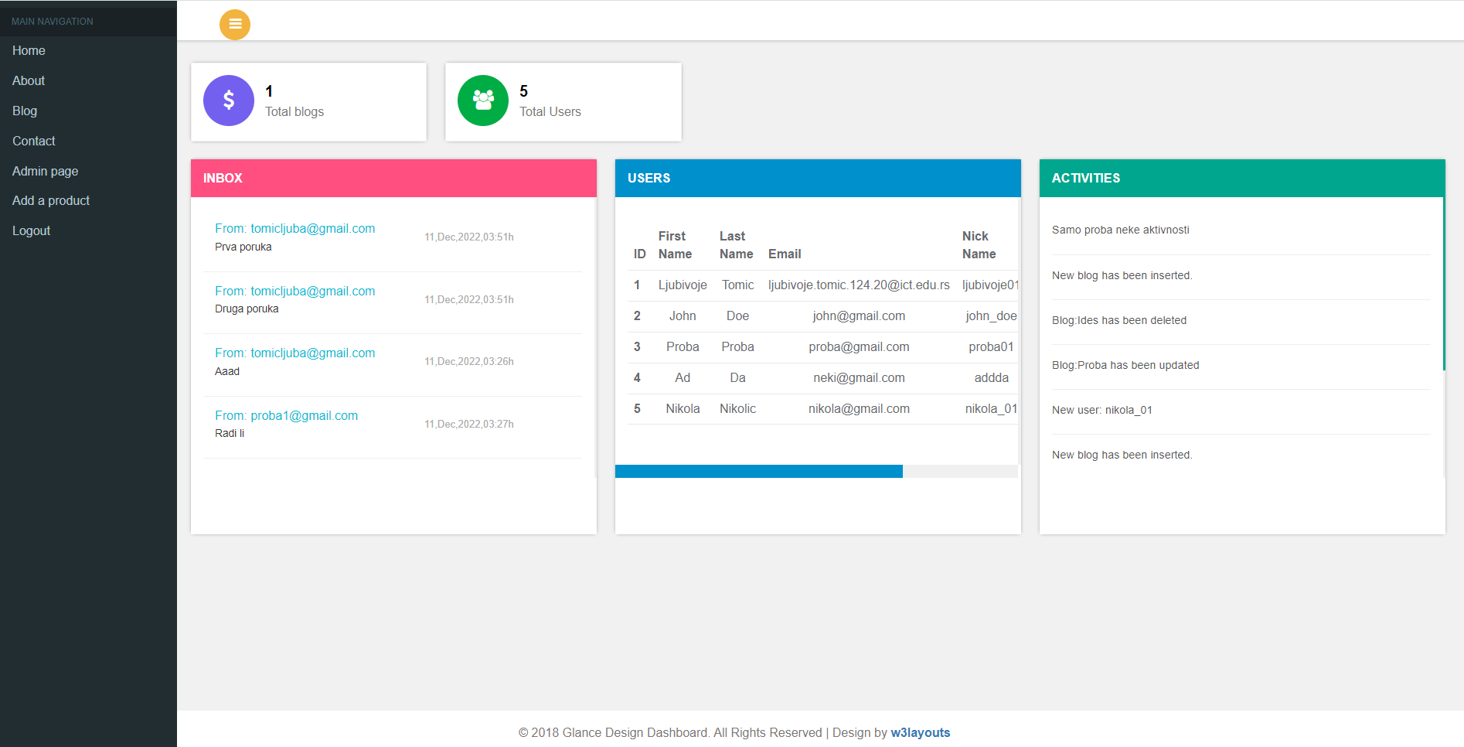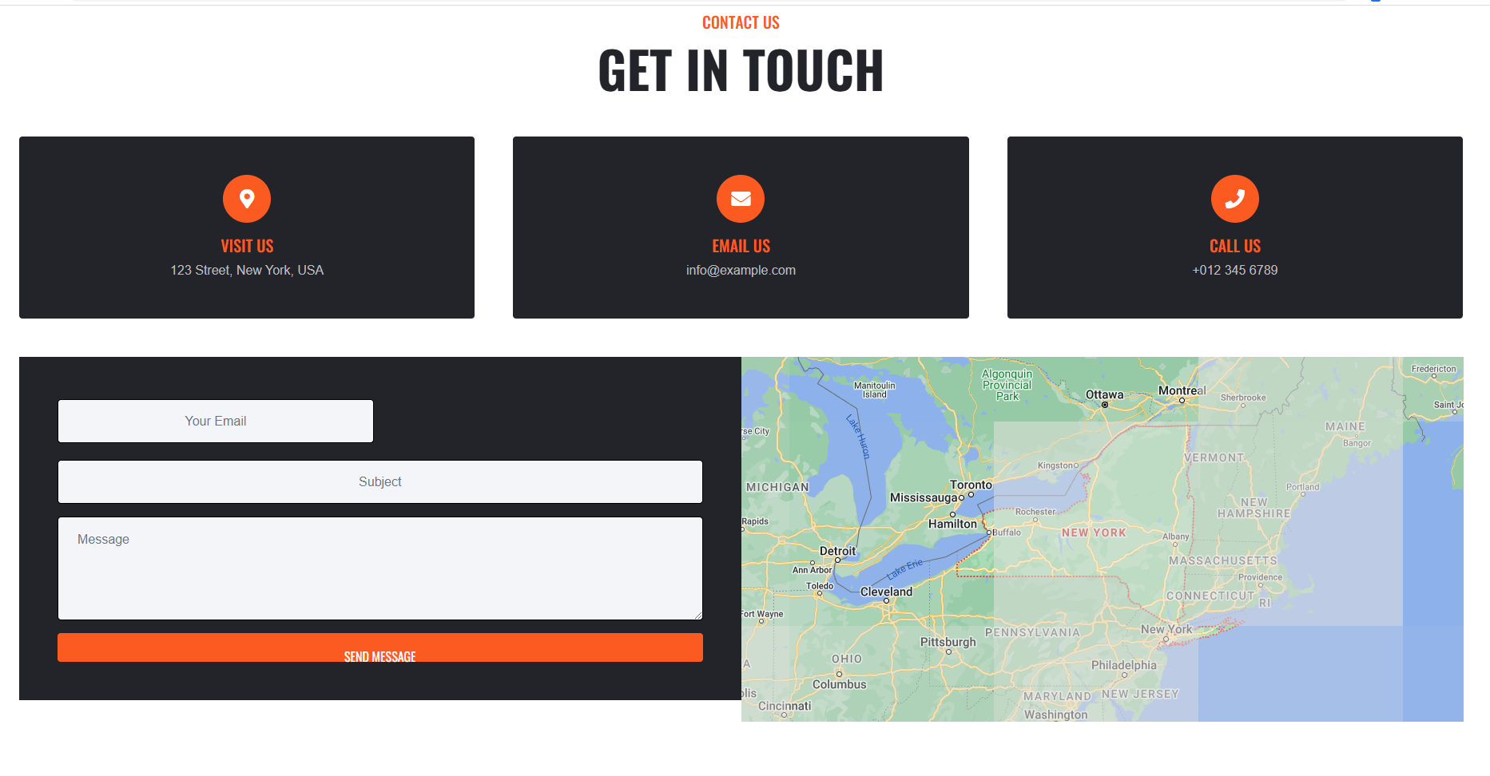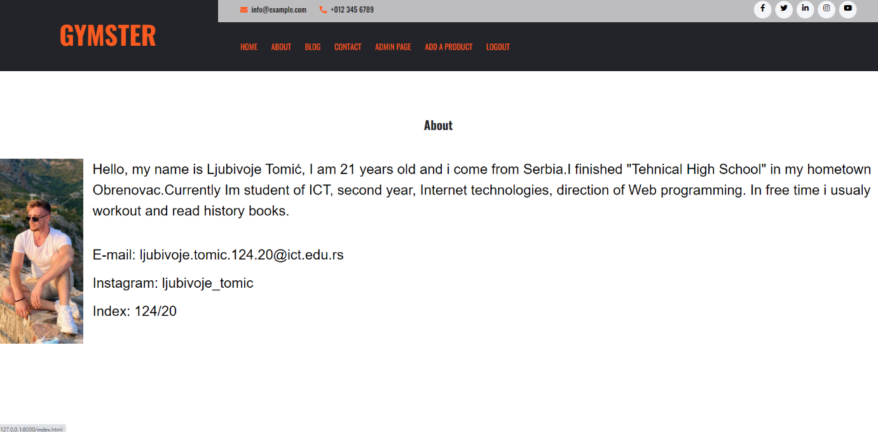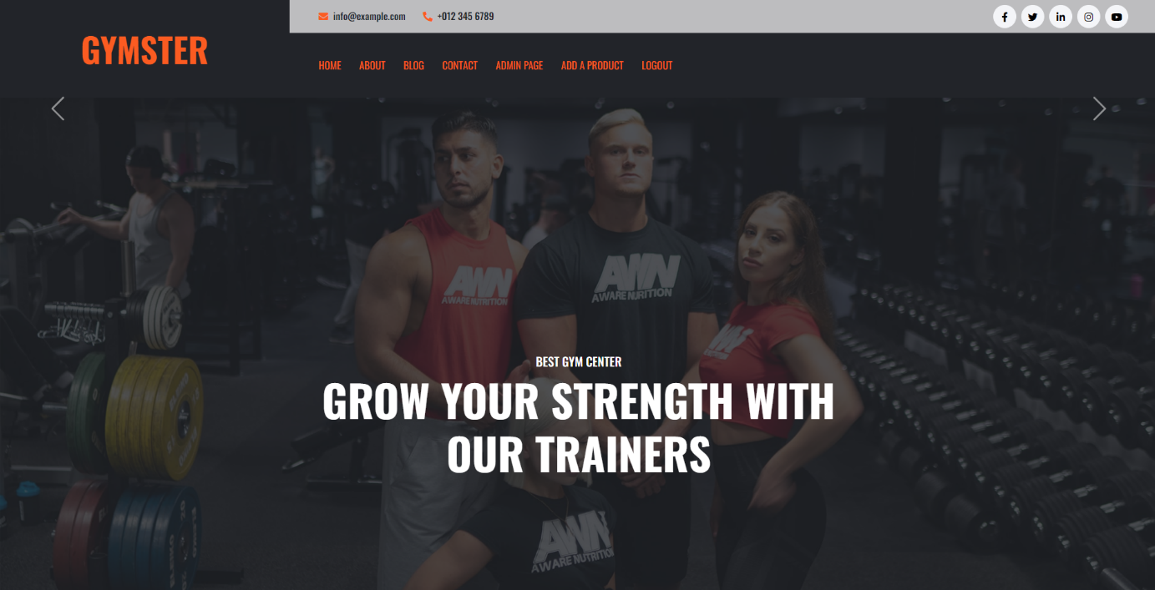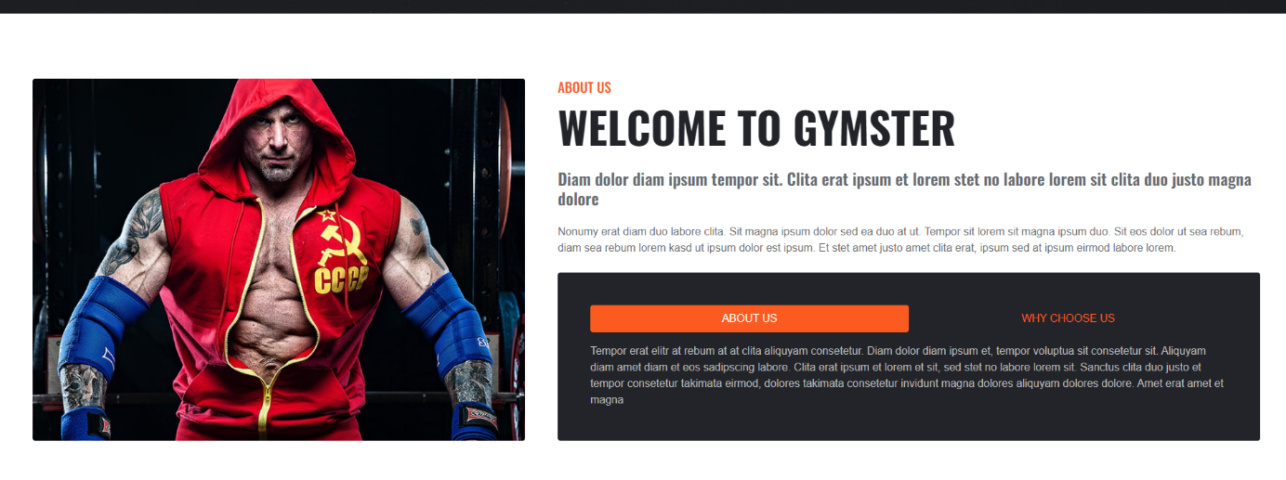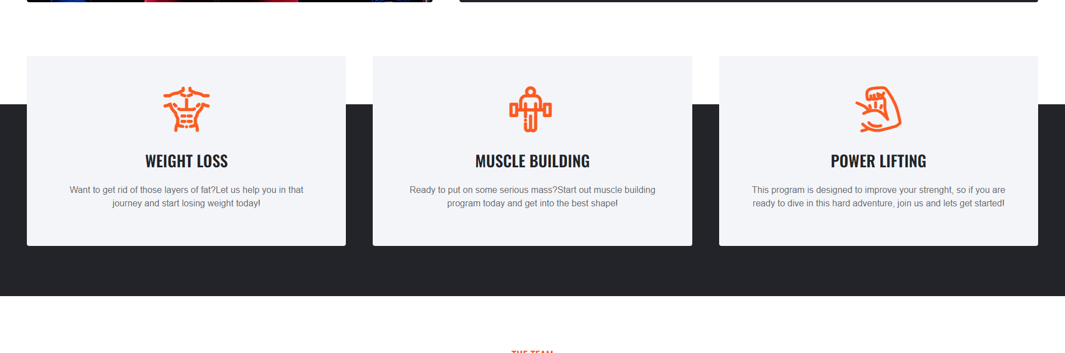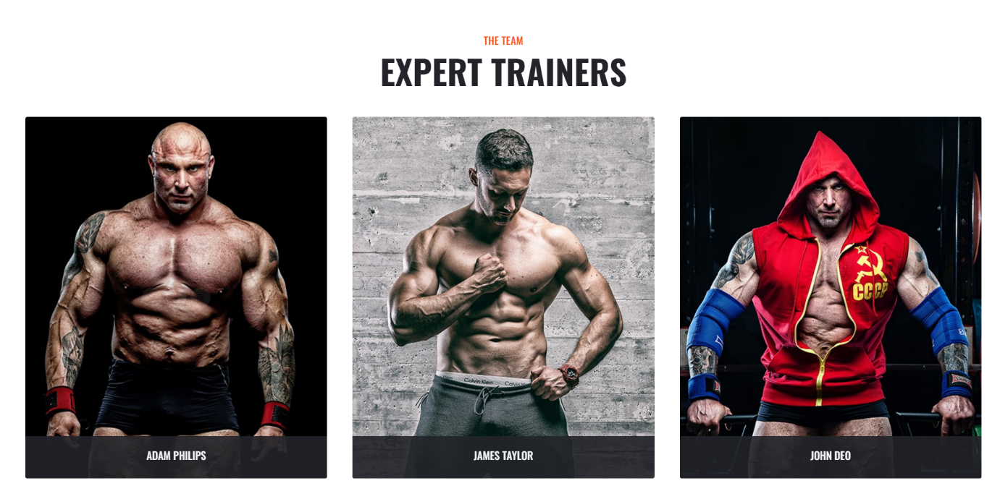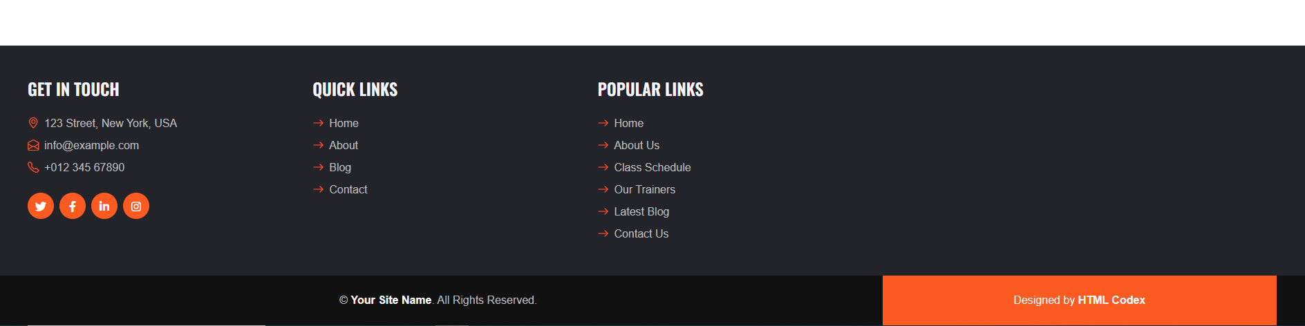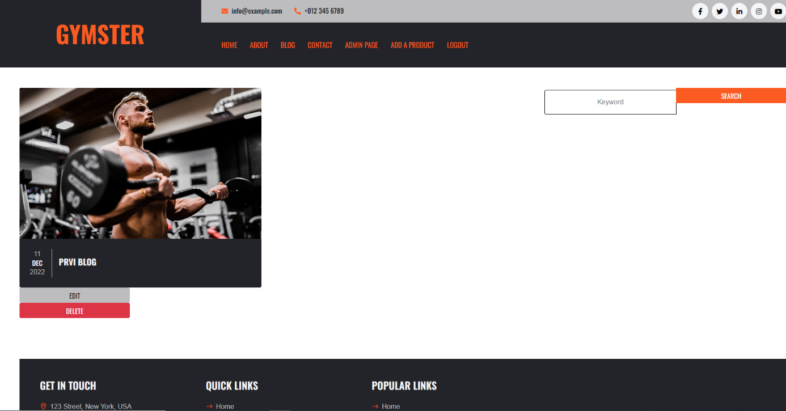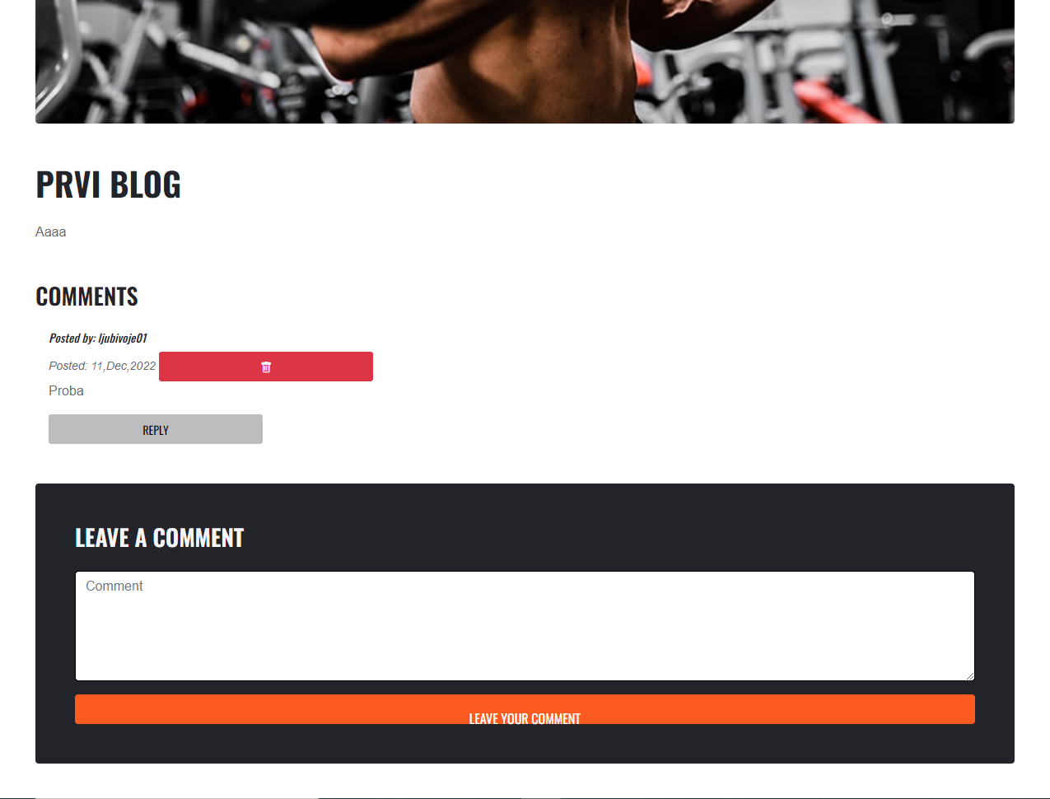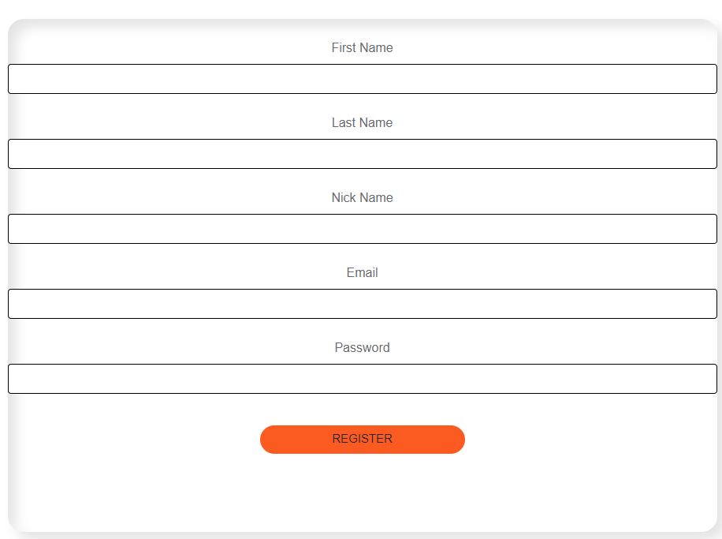



# Baza podataka

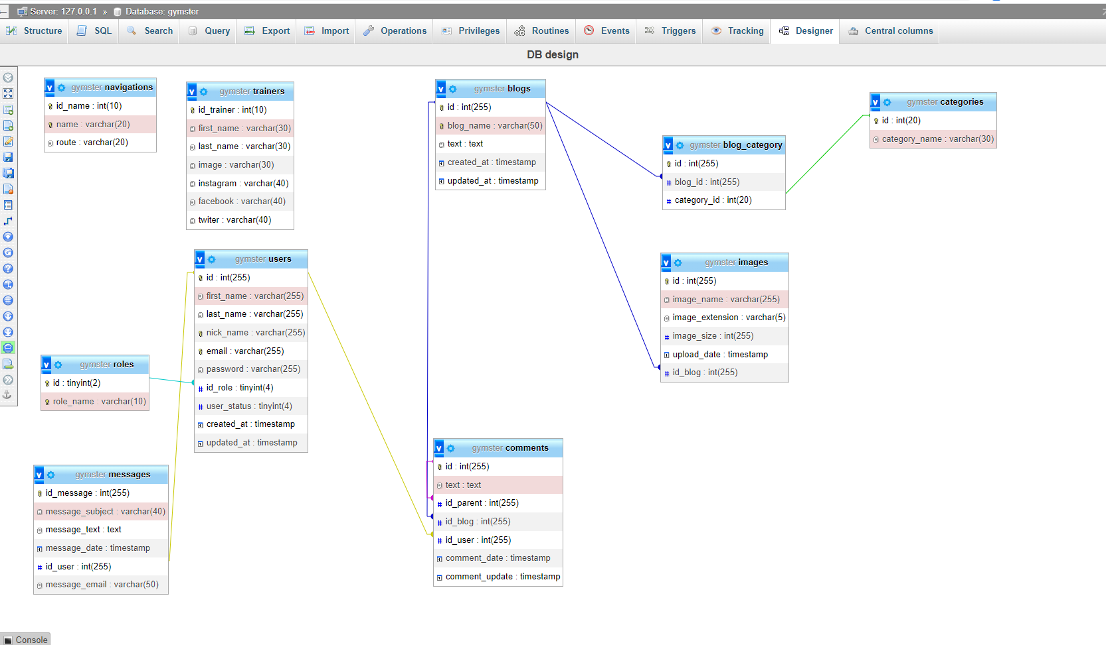

# Kodovi

## Kontroleri

### AdminController

<?php

namespace App\Http\Controllers;

use Illuminate\Http\Request;

use Illuminate\Support\Facades\DB;

use Illuminate\Support\Facades\Storage;

use App\Models\User;

class AdminController extends Controller

{

    function adminPage(){

        $messages=DB::table('messages')->get();

        $users=DB::table('users')->get();

        $roles=DB::table('roles')->get();

        $blogs=DB::table('blogs')->get();

        $activities=DB::table('activities')->get();

        return view("pages.admin.adminHome",[

            "messages"=>$messages,

            "users"=>$users,

            "blogs"=>$blogs,

            "roles"=>$roles,

            "activities"=>$activities

        ]);

    }

    function userEditStatus(Request $request){

       $user = User::find($request->id_user);

       $user->user_status = $request->input('id_status');

       $user->save();

    }

    function userEditRole(Request $request){

        $user = User::find($request->id_user);

        $user->id_role = $request->input('id_role');

        $user->save();

     }

    function activities(){

    }

}

### BaseController

<?php

namespace App\Http\Controllers;

use Illuminate\Http\Request;

class BaseController extends Controller

{

    public $data;

}

### BlogController

<?php

namespace App\Http\Controllers;

use Exception;

use Illuminate\Http\Request;

use Faker;

use Illuminate\Support\Facades\DB;

use Illuminate\Support\Facades\File;

use Carbon\Carbon;

use App\Models\Blog;

use App\Models\Comment;

use App\Models\Category;

use App\Http\Requests\StoreBlog;

use App\Http\Requests\UpdateBlog;

use App\Http\Requests\StoreComment;

use Illuminate\Support\Facades\Storage;

use Image;

use Illuminate\Support\Facades\Auth;

class BlogController extends Controller

{

        public function blogs(Request $request){

        if($request->has("keyword") && !empty($request->get("keyword"))) {

            $keyword=$request->get("keyword");

            $this->data['blogs'] = Blog::where('blog_name','LIKE','%'.$keyword.'%')->orderBy('created_at', 'ASC')->paginate(8);

        }

        else{

            $this->data['blogs'] = DB::table("blogs")->orderBy('created_at', 'ASC')->paginate(8);

        }

        $images = DB::table('images')->get();

        return view('pages.blogs.blog',["data" => $this->data],["images"=>$images]);

    }

    public function singleBlog($id){

            $blog = Blog::where('id', $id)->first();

            $comment = Comment::select("comments.*","users.nick_name")->join('users', 'users.id', '=', 'comments.id_user')->where([

                ['id_blog',$id],

                ['id_parent',null]

                ])->get();

            $comments = Comment::select("comments.*","users.nick_name")->join('users', 'users.id', '=', 'comments.id_user')->where('id_blog',$id)->get();

            $image = DB::table('images')->where('id_blog',$id)->first();

            return view('pages.blogs.single_blog', [

                'blog' => $blog,

                'comment'=>$comment,

                'comments'=>$comments,

                'image'=>$image,

            ]);

    }

    public function blogForm(){

        $categories = Category::all();

        return view('pages.blogs.admin_add_blog',['categories' => $categories]);

    }

    public function insert(StoreBlog $request){

       $data = $request->only('blog_name','text');

       $image = $request->file('blog_img');

       $input['imagename']= time().'.'.$image->extension();

       $extenstion = $request->blog_img->extension();

       $size = $request->blog_img->getSize();

       try{

            DB::beginTransaction();

            $filePath = public_path('assets/img/thumbnail');

            $img = Image::make($image->path());

            $img->resize(800, 500)->save($filePath.'/'.$input['imagename']);

            $filePath = public_path('assets/img/original');

            $image->move($filePath, $input['imagename']);

            $newBlog = Blog::create($data);

            $newBlog->categories()->sync($request->categories);

            $imgUpload = DB::table('images')->insert([

                "image_name"=>$input['imagename'],

                "image_extension"=>$extenstion,

                "image_size"=>$size,

                "id_blog"=>$newBlog->id

            ]);

            $activity = DB::table('activities')->insert([

                "activity_text"=>"New blog has been inserted.",

            ]);

            DB::commit();

            return redirect()->route('blogs');

       }

       catch(Exception $ex){

        DB::rollBack();

        return redirect()->back()->with('error-msg', $ex->getMessage());

        }

    }

    public function deleteBlog($id){

        $blog = Blog::where('id', $id)->first();

        $activity = DB::table('activities')->insert([

            "activity_text"=>"Blog:".$blog->blog_name." has been deleted",

        ]);

        $blog->delete();

        return redirect()->back();

    }

    public function editBlog($id){

        $blog = Blog::find($id);

        $selectedCategories = DB::table("blog_category")->where("blog_category.blog_id",$id)->get();

        return view("pages.blogs.admin_edit_blog",[

            "blog" => $blog,

            "categories" => DB::table("categories")->get(),

            "selectedCategories"=>$selectedCategories

        ]);

    }

    public function updateBlog(UpdateBlog $request, $id){

        try {

            $blog = Blog::find($id);

            if(!$blog) {

                return redirect()->route("notfound");

            }

            $blog_category = DB::table('blog_category')->where('blog_id',$id)->delete();

            $blog->blog_name = $request->get("blog_name");

            $blog->text = $request->get("text");

            $blog->categories()->sync($request->categories);

            if($request->hasFile("blog_img")) {

                $image = $request->file('blog_img');

                $input['imagename']= time().'.'.$image->extension();

                $extenstion = $request->blog_img->extension();

                $size = $request->blog_img->getSize();

                $filePath = public_path('assets/img/thumbnail');

                $img = Image::make($image->path());

                $img->resize(800, 500)->save($filePath.'/'.$input['imagename']);

                $filePath = public_path('assets/img/original');

                $image->move($filePath, $input['imagename']);

                $imgUpload = DB::table('images')->where('id_blog',$id)->update(['image_name'=>$input['imagename']],['image_extension'=>$extenstion],['image_size'=>$size]);

            }

            $blog->save();

            $activity = DB::table('activities')->insert([

                "activity_text"=>"Blog:".$blog->blog_name." has been updated",

            ]);

            return  redirect()->route("blogs");

        }

        catch (\Exception $ex) {

            return redirect()->back()->with('error-msg', $ex->getMessage());        }

    }

    public function postComment(StoreComment $request){

        try{

            $comments = DB::table('comments')->insert([

                'text'=>$request->comment,

                'id_user'=>$request->userId,

                'id_blog'=>$request->blogId,

            ]);

            return redirect()->back();

        }

        catch(Exception $ex){

            return redirect()->back()->with('error-msg', $ex->getMessage());

        }

    }

    public function postReply(Request $request,$idUser,$idBlog,$idComment){

        $comments = DB::table('comments')->insert([

            'text'=>$request->commentReplyText,

            'id_user'=>$idUser,

            'id_blog'=>$idBlog,

            'id_parent'=>$idComment

        ]);

        return redirect()->back();

    }

    public function deleteComment(Request $request){

        $comment = Comment::where('id', $request->id_comment)->first();

        $comment->delete();

    }

}

### ContactController

<?php

namespace App\Http\Controllers;

use Illuminate\Http\Request;

use App\Http\Requests\StoreMessage;

use Illuminate\Support\Facades\DB;

class ContactController extends Controller

{

    public function contact(){

        return view('pages.main.contact');

    }

    public function storeMessages(StoreMessage $request){

        $message = DB::table('messages')->insert([

            "message_subject"=>$request->message_subject,

            "message_text"=>$request->message_text,

            "message_email"=>$request->message_email,

            "id_user"=>$request->id_user

        ]);

    }

}

### Controller

<?php

namespace App\Http\Controllers;

use Illuminate\Foundation\Auth\Access\AuthorizesRequests;

use Illuminate\Foundation\Bus\DispatchesJobs;

use Illuminate\Foundation\Validation\ValidatesRequests;

use Illuminate\Routing\Controller as BaseController;

class Controller extends BaseController

{

    use AuthorizesRequests, DispatchesJobs, ValidatesRequests;

}

### HomeController

<?php

namespace App\Http\Controllers;

use Illuminate\Http\Request;

use Illuminate\Support\Facades\DB;

class HomeController extends BaseController

{

    function index(){

        $this->data['trainers'] = DB::table('trainers')->get();

        return view('pages.main.home',[

            "data" => $this->data,

        ]);

    }

    function aboutMe(){

        return view("pages.main.about");

    }

}

### UserController

<?php

namespace App\Http\Controllers;

use Illuminate\Http\Request;

use App\Http\Requests\StoreUser;

use App\Models\User;

use Illuminate\Support\Facades\Hash;

use Illuminate\Support\Facades\Auth;

use Illuminate\Support\Facades\DB;

class UserController extends Controller

{

    public function form_index(){

        return view('pages.main.join');

    }

    public function form_login_index(){

        return view('pages.main.login');

    }

    public function registerUser(StoreUser $request){

        $data = $request->only('first_name','last_name','nick_name','email','id_role','user_status');

        try{

            $hashedPassword = Hash::make($request->password);

            $activity = DB::table('activities')->insert([

                "activity_text"=>"New user: ".$data['nick_name']

            ]);

            $user = User::create($data+["password"=>$hashedPassword]);

            return redirect()->route('login');

        }

        catch(Exception $ex){

            DB::rollBack();

            return redirect()->back()->with('error-msg', $e->getMessage());

        }

    }

    public function loginUser(Request $request){

        $email = $request->email;

        $password = $request->password;

        $user = User::where('email', $email)->first();

        if(!$user){

            return redirect()->back()->with('error-msg', 'No user found!');

        }

        if(!Hash::check($password, $user->password)){

            return redirect()->back()->with('error-msg', 'Wrong password!');

        }

        if($user->user_status != 1){

            return redirect()->back()->with('error-msg', 'This user is banned!');

        }

        Auth::login($user);

        return redirect()->route('home');

    }

    public function logout(Request $request){

        Auth::logout();

        return redirect()->route('login');

    }

}

## Middlewares

### NotAuthorized

<?php

namespace App\Http\Middleware;

use Closure;

use Illuminate\Http\Request;

use Illuminate\Support\Facades\Auth;

class NotAuthorized

{

    /**

     * Handle an incoming request.

     *

     * @param  \Illuminate\Http\Request  $request

     * @param  \Closure(\Illuminate\Http\Request): (\Illuminate\Http\Response|\Illuminate\Http\RedirectResponse)  $next

     * @return \Illuminate\Http\Response|\Illuminate\Http\RedirectResponse

     */

    public function handle(Request $request, Closure $next)

    {

        if(Auth::check()){

            return redirect()->back();

        }

        return $next($request);

    }

}

### CheckRole

<?php

namespace App\Http\Middleware;

use Closure;

use Illuminate\Http\Request;

use Illuminate\Support\Facades\Auth;

class CheckRole

{

    /**

     * Handle an incoming request.

     *

     * @param  \Illuminate\Http\Request  $request

     * @param  \Closure(\Illuminate\Http\Request): (\Illuminate\Http\Response|\Illuminate\Http\RedirectResponse)  $next

     * @return \Illuminate\Http\Response|\Illuminate\Http\RedirectResponse

     */

    public function handle(Request $request, Closure $next)

    {

        if(Auth::user()->id_role == 2){

            return $next($request);

        }

        return redirect()->back();

    }

}

## Requests

### StoreBlog

<?php

namespace App\Http\Requests;

use Illuminate\Foundation\Http\FormRequest;

class StoreBlog extends FormRequest

{

    /**

     * Determine if the user is authorized to make this request.

     *

     * @return bool

     */

    public function authorize()

    {

        return true;

    }

    /**

     * Get the validation rules that apply to the request.

     *

     * @return array

     */

    public function rules()

    {

        return [

            'blog_name'=>'required|string|max:30',

            'text'=>'required|string|max:255',

            'categories'=>'required|array|min:1',

            'categories.*'=>'required|exists:categories,id',

            'blog_img'=>'required|image|max:3072|mimes:jpg,png'

        ];

    }

}

### StoreComment

<?php

namespace App\Http\Requests;

use Illuminate\Foundation\Http\FormRequest;

class StoreComment extends FormRequest

{

    /**

     * Determine if the user is authorized to make this request.

     *

     * @return bool

     */

    public function authorize()

    {

        return true;

    }

    /**

     * Get the validation rules that apply to the request.

     *

     * @return array

     */

    public function rules()

    {

        return [

            'comment'=>'required|string|max:90',

        ];

    }

}

### StoreMessage

<?php

namespace App\Http\Requests;

use Illuminate\Foundation\Http\FormRequest;

class StoreMessage extends FormRequest

{

    /**

     * Determine if the user is authorized to make this request.

     *

     * @return bool

     */

    public function authorize()

    {

        return true;

    }

    /**

     * Get the validation rules that apply to the request.

     *

     * @return array

     */

    public function rules()

    {

        return [

            'message_email'=>'required|string|max:50|email:rfc,dns',

            'message_subject'=>'required|string|max:30',

            'message_text'=>'required|string|max:90',

        ];

    }

}

### StoreUser

<?php

namespace App\Http\Requests;

use Illuminate\Foundation\Http\FormRequest;

class StoreUser extends FormRequest

{

    /**

     * Determine if the user is authorized to make this request.

     *

     * @return bool

     */

    public function authorize()

    {

        return true;

    }

    /**

     * Get the validation rules that apply to the request.

     *

     * @return array

     */

    public function rules()

    {

        return [

            'first_name'=>'required|string|max:30',

            'last_name'=>'required|string|max:30',

            'nick_name'=>'required|string|max:30|unique:users,nick_name',

            'email'=>'required|string|max:40|unique:users,email|email:rfc,dns',

            'password'=>'required|string|max:30',

            'id_role'=>'1',

            'user_status'=>'1'

        ];

    }

}

### UpdateBlog

<?php

namespace App\Http\Requests;

use Illuminate\Foundation\Http\FormRequest;

class UpdateBlog extends FormRequest

{

    /**

     * Determine if the user is authorized to make this request.

     *

     * @return bool

     */

    public function authorize()

    {

        return true;

    }

    /**

     * Get the validation rules that apply to the request.

     *

     * @return array

     */

    public function rules()

    {

        return [

            'blog_name'=>'required|string|max:30',

            'text'=>'required|string|max:255',

            'categories'=>'required|array|min:1',

            'categories.*'=>'required|exists:categories,id_category',

            'blog_img'=>'image|max:3072|mimes:jpg,png'

        ];

    }

}

## Kernel

<?php

namespace App\Http;

use Illuminate\Foundation\Http\Kernel as HttpKernel;

class Kernel extends HttpKernel

{

    /**

     * The application's global HTTP middleware stack.

     *

     * These middleware are run during every request to your application.

     *

     * @var array

     */

    protected $middleware = [

        // \App\Http\Middleware\TrustHosts::class,

        \App\Http\Middleware\TrustProxies::class,

        \Fruitcake\Cors\HandleCors::class,

        \App\Http\Middleware\PreventRequestsDuringMaintenance::class,

        \Illuminate\Foundation\Http\Middleware\ValidatePostSize::class,

        \App\Http\Middleware\TrimStrings::class,

        \Illuminate\Foundation\Http\Middleware\ConvertEmptyStringsToNull::class,

    ];

    /**

     * The application's route middleware groups.

     *

     * @var array

     */

    protected $middlewareGroups = [

        'web' => [

            \App\Http\Middleware\EncryptCookies::class,

            \Illuminate\Cookie\Middleware\AddQueuedCookiesToResponse::class,

            \Illuminate\Session\Middleware\StartSession::class,

            // \Illuminate\Session\Middleware\AuthenticateSession::class,

            \Illuminate\View\Middleware\ShareErrorsFromSession::class,

            \App\Http\Middleware\VerifyCsrfToken::class,

            \Illuminate\Routing\Middleware\SubstituteBindings::class,

        ],

        'api' => [

            'throttle:api',

            \Illuminate\Routing\Middleware\SubstituteBindings::class,

        ],

    ];

    /**

     * The application's route middleware.

     *

     * These middleware may be assigned to groups or used individually.

     *

     * @var array

     */

    protected $routeMiddleware = [

        'auth' => \App\Http\Middleware\Authenticate::class,

        'auth.basic' => \Illuminate\Auth\Middleware\AuthenticateWithBasicAuth::class,

        'cache.headers' => \Illuminate\Http\Middleware\SetCacheHeaders::class,

        'can' => \Illuminate\Auth\Middleware\Authorize::class,

        'guest' => \App\Http\Middleware\RedirectIfAuthenticated::class,

        'password.confirm' => \Illuminate\Auth\Middleware\RequirePassword::class,

        'signed' => \Illuminate\Routing\Middleware\ValidateSignature::class,

        'throttle' => \Illuminate\Routing\Middleware\ThrottleRequests::class,

        'verified' => \Illuminate\Auth\Middleware\EnsureEmailIsVerified::class,

        'not_authorized' => \App\Http\Middleware\NotAuthorized::class,

        'admin' => \App\Http\Middleware\CheckRole::class,

    ];

}

## Models

### Blog

<?php

namespace App\Models;

use Illuminate\Database\Eloquent\Factories\HasFactory;

use Illuminate\Database\Eloquent\Model;

class Blog extends Model

{

    use HasFactory;

    protected $fillable = ["blog_name", "blog_img","text"];

    public function categories(){

        return $this->belongsToMany(Category::class);

    }

}

### Category

<?php

namespace App\Models;

use Illuminate\Database\Eloquent\Factories\HasFactory;

use Illuminate\Database\Eloquent\Model;

class Category extends Model

{

    use HasFactory;

    public function blogs(){

        return $this->belongsToMany(Blog::class);

    }

}

### Comment

<?php

namespace App\Models;

use Illuminate\Database\Eloquent\Factories\HasFactory;

use Illuminate\Database\Eloquent\Model;

class Comment extends Model

{

    use HasFactory;

}

### Image

<?php

namespace App\Models;

use Illuminate\Database\Eloquent\Factories\HasFactory;

use Illuminate\Database\Eloquent\Model;

class Image extends Model

{

    use HasFactory;

    protected $fillable = ["image_name", "image_extension","image_size","id_blog"];

}

### User

<?php

namespace App\Models;

use Illuminate\Contracts\Auth\MustVerifyEmail;

use Illuminate\Database\Eloquent\Factories\HasFactory;

use Illuminate\Foundation\Auth\User as Authenticatable;

use Illuminate\Notifications\Notifiable;

class User extends Authenticatable

{

    use  HasFactory, Notifiable;

    protected $fillable = [

        'first_name',

        'last_name',

        'nick_name',

        'email',

        'password',

    ];

    protected $hidden = [

        'password',

        'remember_token',

    ];

    public function comments()

    {

        return $this->hasMany(Comment::class);

    }

}

## Providers

### AppServiceProvider

<?php

namespace App\Providers;

use Illuminate\Support\ServiceProvider;

use Illuminate\Support\Facades\View;

use Illuminate\Support\Facades\DB;

class AppServiceProvider extends ServiceProvider

{

    private $nav;

    /**

     * Register any application services.

     *

     * @return void

     */

    public function register()

    {

        //

    }

    /**

     * Bootstrap any application services.

     *

     * @return void

     */

    public function boot()

    {

        $nav = DB::table('navigations')->get();

        View::share('navigation',$nav);

    }

}

## View/Components

### Card

<?php

namespace App\View\Components;

use Illuminate\View\Component;

class card extends Component

{

    public $img;

    public $alt;

    public $text;

    public $title;

    /**

     * Create a new component instance.

     *

     * @return void

     */

    public function __construct($img,$alt,$text,$title)

    {

        $this->img=$img;

        $this->alt=$alt;

        $this->text=$text;

        $this->title=$title;

    }

    /**

     * Get the view / contents that represent the component.

     *

     * @return \Illuminate\Contracts\View\View|\Closure|string

     */

    public function render()

    {

        return view('components.card');

    }

}

## Config

### App

<?php

return [

    /*

    |--------------------------------------------------------------------------

    | Application Name

    |--------------------------------------------------------------------------

    |

    | This value is the name of your application. This value is used when the

    | framework needs to place the application's name in a notification or

    | any other location as required by the application or its packages.

    |

    */

    'name' => env('APP_NAME', 'Laravel'),

    /*

    |--------------------------------------------------------------------------

    | Application Environment

    |--------------------------------------------------------------------------

    |

    | This value determines the "environment" your application is currently

    | running in. This may determine how you prefer to configure various

    | services the application utilizes. Set this in your ".env" file.

    |

    */

    'env' => env('APP_ENV', 'production'),

    /*

    |--------------------------------------------------------------------------

    | Application Debug Mode

    |--------------------------------------------------------------------------

    |

    | When your application is in debug mode, detailed error messages with

    | stack traces will be shown on every error that occurs within your

    | application. If disabled, a simple generic error page is shown.

    |

    */

    'debug' => (bool) env('APP_DEBUG', false),

    /*

    |--------------------------------------------------------------------------

    | Application URL

    |--------------------------------------------------------------------------

    |

    | This URL is used by the console to properly generate URLs when using

    | the Artisan command line tool. You should set this to the root of

    | your application so that it is used when running Artisan tasks.

    |

    */

    'url' => env('APP_URL', 'http://localhost'),

    'asset_url' => env('ASSET_URL', null),

    /*

    |--------------------------------------------------------------------------

    | Application Timezone

    |--------------------------------------------------------------------------

    |

    | Here you may specify the default timezone for your application, which

    | will be used by the PHP date and date-time functions. We have gone

    | ahead and set this to a sensible default for you out of the box.

    |

    */

    'timezone' => 'UTC',

    /*

    |--------------------------------------------------------------------------

    | Application Locale Configuration

    |--------------------------------------------------------------------------

    |

    | The application locale determines the default locale that will be used

    | by the translation service provider. You are free to set this value

    | to any of the locales which will be supported by the application.

    |

    */

    'locale' => 'en',

    /*

    |--------------------------------------------------------------------------

    | Application Fallback Locale

    |--------------------------------------------------------------------------

    |

    | The fallback locale determines the locale to use when the current one

    | is not available. You may change the value to correspond to any of

    | the language folders that are provided through your application.

    |

    */

    'fallback_locale' => 'en',

    /*

    |--------------------------------------------------------------------------

    | Faker Locale

    |--------------------------------------------------------------------------

    |

    | This locale will be used by the Faker PHP library when generating fake

    | data for your database seeds. For example, this will be used to get

    | localized telephone numbers, street address information and more.

    |

    */

    'faker_locale' => 'en_US',

    /*

    |--------------------------------------------------------------------------

    | Encryption Key

    |--------------------------------------------------------------------------

    |

    | This key is used by the Illuminate encrypter service and should be set

    | to a random, 32 character string, otherwise these encrypted strings

    | will not be safe. Please do this before deploying an application!

    |

    */

    'key' => env('APP_KEY'),

    'cipher' => 'AES-256-CBC',

    /*

    |--------------------------------------------------------------------------

    | Autoloaded Service Providers

    |--------------------------------------------------------------------------

    |

    | The service providers listed here will be automatically loaded on the

    | request to your application. Feel free to add your own services to

    | this array to grant expanded functionality to your applications.

    |

    */

    'providers' => [

        /*

         * Laravel Framework Service Providers...

         */

        Illuminate\Auth\AuthServiceProvider::class,

        Illuminate\Broadcasting\BroadcastServiceProvider::class,

        Illuminate\Bus\BusServiceProvider::class,

        Illuminate\Cache\CacheServiceProvider::class,

        Illuminate\Foundation\Providers\ConsoleSupportServiceProvider::class,

        Illuminate\Cookie\CookieServiceProvider::class,

        Illuminate\Database\DatabaseServiceProvider::class,

        Illuminate\Encryption\EncryptionServiceProvider::class,

        Illuminate\Filesystem\FilesystemServiceProvider::class,

        Illuminate\Foundation\Providers\FoundationServiceProvider::class,

        Illuminate\Hashing\HashServiceProvider::class,

        Illuminate\Mail\MailServiceProvider::class,

        Illuminate\Notifications\NotificationServiceProvider::class,

        Illuminate\Pagination\PaginationServiceProvider::class,

        Illuminate\Pipeline\PipelineServiceProvider::class,

        Illuminate\Queue\QueueServiceProvider::class,

        Illuminate\Redis\RedisServiceProvider::class,

        Illuminate\Auth\Passwords\PasswordResetServiceProvider::class,

        Illuminate\Session\SessionServiceProvider::class,

        Illuminate\Translation\TranslationServiceProvider::class,

        Illuminate\Validation\ValidationServiceProvider::class,

        Illuminate\View\ViewServiceProvider::class,

        Intervention\Image\ImageServiceProvider::class,

        /*

         * Package Service Providers...

         */

        /*

         * Application Service Providers...

         */

        App\Providers\AppServiceProvider::class,

        App\Providers\AuthServiceProvider::class,

        // App\Providers\BroadcastServiceProvider::class,

        App\Providers\EventServiceProvider::class,

        App\Providers\RouteServiceProvider::class,

    ],

    /*

    |--------------------------------------------------------------------------

    | Class Aliases

    |--------------------------------------------------------------------------

    |

    | This array of class aliases will be registered when this application

    | is started. However, feel free to register as many as you wish as

    | the aliases are "lazy" loaded so they don't hinder performance.

    |

    */

    'aliases' => [

        'App' => Illuminate\Support\Facades\App::class,

        'Arr' => Illuminate\Support\Arr::class,

        'Artisan' => Illuminate\Support\Facades\Artisan::class,

        'Auth' => Illuminate\Support\Facades\Auth::class,

        'Blade' => Illuminate\Support\Facades\Blade::class,

        'Broadcast' => Illuminate\Support\Facades\Broadcast::class,

        'Bus' => Illuminate\Support\Facades\Bus::class,

        'Cache' => Illuminate\Support\Facades\Cache::class,

        'Config' => Illuminate\Support\Facades\Config::class,

        'Cookie' => Illuminate\Support\Facades\Cookie::class,

        'Crypt' => Illuminate\Support\Facades\Crypt::class,

        'Date' => Illuminate\Support\Facades\Date::class,

        'DB' => Illuminate\Support\Facades\DB::class,

        'Eloquent' => Illuminate\Database\Eloquent\Model::class,

        'Event' => Illuminate\Support\Facades\Event::class,

        'File' => Illuminate\Support\Facades\File::class,

        'Gate' => Illuminate\Support\Facades\Gate::class,

        'Hash' => Illuminate\Support\Facades\Hash::class,

        'Http' => Illuminate\Support\Facades\Http::class,

        'Js' => Illuminate\Support\Js::class,

        'Lang' => Illuminate\Support\Facades\Lang::class,

        'Log' => Illuminate\Support\Facades\Log::class,

        'Mail' => Illuminate\Support\Facades\Mail::class,

        'Notification' => Illuminate\Support\Facades\Notification::class,

        'Password' => Illuminate\Support\Facades\Password::class,

        'Queue' => Illuminate\Support\Facades\Queue::class,

        'RateLimiter' => Illuminate\Support\Facades\RateLimiter::class,

        'Redirect' => Illuminate\Support\Facades\Redirect::class,

        // 'Redis' => Illuminate\Support\Facades\Redis::class,

        'Request' => Illuminate\Support\Facades\Request::class,

        'Response' => Illuminate\Support\Facades\Response::class,

        'Route' => Illuminate\Support\Facades\Route::class,

        'Schema' => Illuminate\Support\Facades\Schema::class,

        'Session' => Illuminate\Support\Facades\Session::class,

        'Storage' => Illuminate\Support\Facades\Storage::class,

        'Str' => Illuminate\Support\Str::class,

        'URL' => Illuminate\Support\Facades\URL::class,

        'Validator' => Illuminate\Support\Facades\Validator::class,

        'View' => Illuminate\Support\Facades\View::class,

        'Image' => Intervention\Image\Facades\Image::class

    ],

];

## CSS

### Style.css

/********** Template CSS **********/

:root {

    --primary: #FB5B21;

    --secondary: #BDBDBF;

    --light: #F4F5F8;

    --dark: #222429;

}

[class^="flaticon-"]:before,

[class*=" flaticon-"]:before,

[class^="flaticon-"]:after,

[class*=" flaticon-"]:after {

    font-size: inherit;

    margin-left: 0;

}

h1,

h2,

.font-weight-bold {

    font-weight: 700 !important;

}

h3,

h4,

.font-weight-semi-bold {

    font-weight: 600 !important;

}

h5,

h6,

.font-weight-medium {

    font-weight: 500 !important;

}

.btn {

    font-family: 'Oswald', sans-serif;

    text-transform: uppercase;

    transition: .5s;

}

.btn-primary {

    color: #FFFFFF;

}

.btn-square {

    width: 38px;

    height: 38px;

}

.btn-sm-square {

    width: 30px;

    height: 30px;

}

.btn-lg-square {

    width: 48px;

    height: 48px;

}

.btn-square,

.btn-sm-square,

.btn-lg-square {

    padding-left: 0;

    padding-right: 0;

    text-align: center;

}

.back-to-top {

    position: fixed;

    display: none;

    right: 30px;

    bottom: 0;

    border-radius: 0;

    z-index: 99;

}

.navbar-dark .navbar-nav .nav-link {

    font-family: 'Oswald', sans-serif;

    margin-right: 30px;

    padding: 40px 0;

    color: var(--light);

    font-size: 17px;

    text-transform: uppercase;

    outline: none;

}

.navbar-dark .navbar-nav .nav-link:hover,

.navbar-dark .navbar-nav .nav-link.active {

    color: var(--primary);

}

@media (max-width: 991.98px) {

    .navbar-dark .navbar-nav .nav-link  {

        margin-right: 0;

        padding: 10px 0;

    }

}

.carousel-caption {

    top: 0;

    left: 0;

    right: 0;

    bottom: 0;

    background: rgba(34, 36, 41, .8);

    z-index: 1;

}

@media (max-width: 576px) {

    .carousel-caption h4 {

        font-size: 18px;

        font-weight: 500 !important;

    }

    .carousel-caption h1 {

        font-size: 30px;

        font-weight: 600 !important;

    }

}

.carousel-control-prev,

.carousel-control-next {

    width: 10%;

}

.carousel-control-prev-icon,

.carousel-control-next-icon {

    width: 3rem;

    height: 3rem;

}

.bg-hero {

    background: linear-gradient(rgba(34, 36, 41, .8), rgba(34, 36, 41, .8)), url(../img/carousel-1.jpg) top center no-repeat;

    background-size: cover;

}

.programe::after {

    position :absolute;

    content: "";

    width: 100%;

    height: calc(100% - 45px);

    top: 135px;

    left: 0;

    background: var(--dark);

    z-index: -1;

}

.team-item img {

    transition: .5s;

}

.team-item:hover img {

    transform: scale(1.2);

}

.team-item .team-overlay {

    position: absolute;

    top: 50%;

    right: 50%;

    bottom: 50%;

    left: 50%;

    display: flex;

    align-items: center;

    justify-content: center;

    background: rgba(34, 36, 41, .9);

    transition: .5s;

    opacity: 0;

}

.team-item:hover .team-overlay {

    top: 0;

    right: 0;

    bottom: 0;

    left: 0;

    opacity: 1;

}

.testimonial-carousel .owl-nav {

    margin-top: 30px;

    display: flex;

    justify-content: start;

}

.testimonial-carousel .owl-nav .owl-prev,

.testimonial-carousel .owl-nav .owl-next{

    position: relative;

    margin: 0 5px;

    width: 45px;

    height: 45px;

    display: flex;

    align-items: center;

    justify-content: center;

    color: #FFFFFF;

    background: var(--primary);

    font-size: 22px;

    border-radius: 45px;

    transition: .5s;

}

.testimonial-carousel .owl-nav .owl-prev:hover,

.testimonial-carousel .owl-nav .owl-next:hover {

    color: var(--dark);

}

.testimonial-carousel .owl-item img {

    width: 90px;

    height: 90px;

}

.blog-item img {

    transition: .5s;

}

.blog-item:hover img {

    transform: scale(1.2);

}

@media (min-width: 991.98px) {

    .credit {

        background: var(--primary);

    }

}

*,

*:before,

*:after {

  box-sizing: border-box;

  margin: 0;

  padding: 0;

}

body {

  font-family: "Open Sans", Helvetica, Arial, sans-serif;

  background: #ffffff;

}

input,

button {

  border: none;

  outline: none;

  background: none;

  font-family: "Open Sans", Helvetica, Arial, sans-serif;

}

.tip {

  font-size: 20px;

  margin: 40px auto 50px;

  text-align: center;

}

.cont {

  border-radius: 20px;

  overflow: hidden;

  position: relative;

  width: 900px;

  height: 650px;

  margin: 0 auto 100px;

  background: #fff;

  box-shadow: -10px -10px 15px rgba(255, 255, 255, 0.3),

    10px 10px 15px rgba(70, 70, 70, 0.15),

    inset -10px -10px 15px rgba(255, 255, 255, 0.3),

    inset 10px 10px 15px rgba(70, 70, 70, 0.15);

}

.form {

  position: relative;

  width: 640px;

  height: 100%;

  -webkit-transition: -webkit-transform 1.2s ease-in-out;

  transition: -webkit-transform 1.2s ease-in-out;

  transition: transform 1.2s ease-in-out;

  transition: transform 1.2s ease-in-out, -webkit-transform 1.2s ease-in-out;

  padding: 50px 30px 0;

}

.sub-cont {

  overflow: hidden;

  position: absolute;

  left: 640px;

  top: 0;

  width: 900px;

  height: 100%;

  padding-left: 260px;

  background: #fff;

  -webkit-transition: -webkit-transform 1.2s ease-in-out;

  transition: -webkit-transform 1.2s ease-in-out;

  transition: transform 1.2s ease-in-out;

  transition: transform 1.2s ease-in-out, -webkit-transform 1.2s ease-in-out;

}

.cont.s--signup .sub-cont {

  -webkit-transform: translate3d(-640px, 0, 0);

  transform: translate3d(-640px, 0, 0);

}

button {

  display: block;

  margin: 0 auto;

  width: 260px;

  height: 36px;

  border-radius: 30px;

  color: #fff;

  font-size: 15px;

  cursor: pointer;

}

.img {

  overflow: hidden;

  z-index: 2;

  position: absolute;

  left: 0;

  top: 0;

  width: 260px;

  height: 100%;

  padding-top: 360px;

}

.img:before {

  content: "";

  position: absolute;

  right: 0;

  top: 0;

  width: 900px;

  height: 100%;

  background-image: url("ext.jpg");

  opacity: 0.8;

  background-size: cover;

  -webkit-transition: -webkit-transform 1.2s ease-in-out;

  transition: transform 1.2s ease-in-out;

  transition: transform 1.2s ease-in-out, -webkit-transform 1.2s ease-in-out;

}

.img:after {

  content: "";

  position: absolute;

  left: 0;

  top: 0;

  width: 100%;

  height: 100%;

  background: rgba(0, 0, 0, 0.6);

}

.cont.s--signup .img:before {

  -webkit-transform: translate3d(640px, 0, 0);

  transform: translate3d(640px, 0, 0);

}

.img__text {

  z-index: 2;

  position: absolute;

  left: 0;

  top: 50px;

  width: 100%;

  padding: 0 20px;

  text-align: center;

  color: #fff;

  -webkit-transition: -webkit-transform 1.2s ease-in-out;

  transition: -webkit-transform 1.2s ease-in-out;

  transition: transform 1.2s ease-in-out;

  transition: transform 1.2s ease-in-out, -webkit-transform 1.2s ease-in-out;

}

.img__text h2 {

  margin-bottom: 10px;

  font-weight: normal;

}

.img__text p {

  font-size: 14px;

  line-height: 1.5;

}

.cont.s--signup .img__text.m--up {

  -webkit-transform: translateX(520px);

  transform: translateX(520px);

}

.img__text.m--in {

  -webkit-transform: translateX(-520px);

  transform: translateX(-520px);

}

.cont.s--signup .img__text.m--in {

  -webkit-transform: translateX(0);

  transform: translateX(0);

}

.img__btn {

  overflow: hidden;

  color: #222429 !important;

  z-index: 2;

  position: relative;

  width: 100px;

  height: 36px;

  margin: 0 auto;

  background: transparent;

  color: #fff;

  text-transform: uppercase;

  font-size: 15px;

  cursor: pointer;

}

.img__btn:after {

  content: "";

  z-index: 2;

  position: absolute;

  left: 0;

  top: 0;

  width: 100%;

  height: 100%;

  border: 2px solid #fff;

  border-radius: 30px;

}

.img__btn span {

  position: absolute;

  left: 0;

  top: 0;

  display: -webkit-box;

  display: flex;

  -webkit-box-pack: center;

  justify-content: center;

  -webkit-box-align: center;

  align-items: center;

  width: 100%;

  height: 100%;

  -webkit-transition: -webkit-transform 1.2s;

  transition: -webkit-transform 1.2s;

  transition: transform 1.2s;

  transition: transform 1.2s, -webkit-transform 1.2s;

}

.img__btn span.m--in {

  -webkit-transform: translateY(-72px);

  transform: translateY(-72px);

}

.cont.s--signup .img__btn span.m--in {

  -webkit-transform: translateY(0);

  transform: translateY(0);

}

.cont.s--signup .img__btn span.m--up {

  -webkit-transform: translateY(72px);

  transform: translateY(72px);

}

h2 {

  width: 100%;

  font-size: 26px;

  text-align: center;

}

label {

  display: block;

  width: 260px;

  margin: 25px auto 0;

  text-align: center;

}

label span {

  font-size: 12px;

  color: #cfcfcf;

  text-transform: uppercase;

}

input {

  display: block;

  width: 100%;

  margin-top: 5px;

  padding-bottom: 5px;

  font-size: 16px;

  border-bottom: 1px solid rgba(0, 0, 0, 0.4);

  text-align: center;

}

.forgot-pass {

  margin-top: 15px;

  text-align: center;

  font-size: 12px;

  color: #cfcfcf;

}

.submit {

  margin-top: 40px;

  margin-bottom: 20px;

  background: #fb5b21;

  text-transform: uppercase;

  color: #222429;

}

.fb-btn {

  border: 2px solid #d3dae9;

  color: #8fa1c7;

}

.fb-btn span {

  font-weight: bold;

  color: #455a81;

}

.sign-in {

  -webkit-transition-timing-function: ease-out;

  transition-timing-function: ease-out;

}

.cont.s--signup .sign-in {

  -webkit-transition-timing-function: ease-in-out;

  transition-timing-function: ease-in-out;

  -webkit-transition-duration: 1.2s;

  transition-duration: 1.2s;

  -webkit-transform: translate3d(640px, 0, 0);

  transform: translate3d(640px, 0, 0);

}

.sign-up {

  -webkit-transform: translate3d(-900px, 0, 0);

  transform: translate3d(-900px, 0, 0);

}

.cont.s--signup .sign-up {

  -webkit-transform: translate3d(0, 0, 0);

  transform: translate3d(0, 0, 0);

}

.form-control{

  border: 1px solid black !important;

}

.bio{

  height: auto;

  flex-direction: column;

  padding: 100px 0;

  display: flex;

  align-items: center;

  color: black;

  }

  .bioBackground{

  background-color: #000000;

  }

  #aboutMe{

  margin: 50px auto;

  }

  #pic{

  height: 400px;

  float: left;

  margin: 0 20px 20px 0;

  }

  #aboutMe p{

  font-size: 30px;

  }

  .info{

  margin-top: 50px;

  }

## JS

### Main.js

// (function ($) {

//     "use strict";

//     // Dropdown on mouse hover

//     $(document).ready(function () {

//         function toggleNavbarMethod() {

//             if ($(window).width() > 992) {

//                 $('.navbar .dropdown').on('mouseover', function () {

//                     $('.dropdown-toggle', this).trigger('click');

//                 }).on('mouseout', function () {

//                     $('.dropdown-toggle', this).trigger('click').blur();

//                 });

//             } else {

//                 $('.navbar .dropdown').off('mouseover').off('mouseout');

//             }

//         }

//         toggleNavbarMethod();

//         $(window).resize(toggleNavbarMethod);

//     });

//     // Back to top button

//     $(window).scroll(function () {

//         if ($(this).scrollTop() > 100) {

//             $('.back-to-top').fadeIn('slow');

//         } else {

//             $('.back-to-top').fadeOut('slow');

//         }

//     });

//     $('.back-to-top').click(function () {

//         $('html, body').animate({scrollTop: 0}, 1500, 'easeInOutExpo');

//         return false;

//     });

//     // Testimonials carousel

//     $(".testimonial-carousel").owlCarousel({

//         autoplay: true,

//         smartSpeed: 1000,

//         items: 1,

//         dots: false,

//         loop: true,

//         nav : true,

//         navText : [

//             '<i class="bi bi-arrow-left"></i>',

//             '<i class="bi bi-arrow-right"></i>'

//         ],

//     });

// })(jQuery);

window.onload=function(){

    $('.replyBTN button').on('click', function(){

        let form = $(this).parent().children('.printReplyForm')[0];

        let printDiv = $(form).children('form')[0];

        if($(printDiv).children('.replyFormCheck').length == 0){

        $(printDiv).append(`<div class="col-12 replyFormCheck"><textarea class="form-control bg-white border-0" rows="5" name="commentReplyText" placeholder="Reply"></textarea>

        </div><div class="col-12"><button class="btn btn-primary w-100 py-3" type="submit">Post</button><button class="btn btn-primary w-100 py-3 closeReplyBtn">Cancel</button></div></div>`);

        }

        else{

            $(printDiv).toggle();

            $(".closeReplyBtn").on("click", function(e){

                e.preventDefault();

                $(printDiv).toggle();

            })

        }

        $(".closeReplyBtn").on("click", function(e){

            e.preventDefault();

            $(printDiv).toggle();

        })

    })

    $(".deleteComment").on('click',function(e){

      e.preventDefault();

      let comment = $(this).data("id")

      let data = {

          "id_comment":comment,

        }

        console.log(data)

      $.ajax({

        url: `/deleteComment`,

        type:"DELETE",

        beforeSend: function(request) { request.setRequestHeader("X-CSRF-TOKEN", csrfToken)},

        data: data,

        success:function(){

          alert("Your comment has been deleted.");

          location.reload();

        },

        error: function(xhr) {

          console.error(xhr)

        },

        });

    })

    // $(".editComment").on('click',function(e){

    //   e.preventDefault();

    //   let comment = $(this).data("id")

    //   let data = {

    //       "id_comment":comment,

    //     }

    //     console.log(data)

    //   $.ajax({

    //     url: `/blogs/`,

    //     type:"GET",

    //     beforeSend: function(request) { request.setRequestHeader("X-CSRF-TOKEN", csrfToken)},

    //     data: data,

    //     success:function(){

    //     },

    //     error: function(xhr) {

    //       console.error(xhr)

    //     },

    //     });

    // })

    if(window.location.pathname.indexOf("/adminPage") > -1){

        $('.status').on('change',function(e){

            e.preventDefault();

            let status = $(this).val();

            let user = $(this).data("id")

            let data = {

                "id_status":status,

                "id_user":user

              }

            $.ajax({

              url: `/adminPage/userEditStatus`,

              type:"PATCH",

              beforeSend: function(request) { request.setRequestHeader("X-CSRF-TOKEN", csrfToken)},

              data: data,

              success:function(){

                location.reload();

              },

              error: function(xhr) {

                console.error(xhr)

              },

              });

            });

        $('.role').on('change',function(e){

                e.preventDefault();

                let role = $(this).val();

                let user = $(this).data("id")

                let data = {

                    "id_role":role,

                    "id_user":user

                  }

                $.ajax({

                  url: `/adminPage/userEditRole`,

                  type:"PATCH",

                  beforeSend: function(request) { request.setRequestHeader("X-CSRF-TOKEN", csrfToken)},

                  data: data,

                  success:function(){

                    location.reload();

                  },

                  error: function(xhr) {

                    console.error(xhr)

                  },

                  });

            });

    }

    if(window.location.pathname.indexOf("/contact") > -1){

      let formSubmit = document.getElementById("sendMSG");

      formSubmit.addEventListener("submit",(e)=>{

      e.preventDefault();

      let user = $("#message_subject").data("id")

      let subject = $("#message_subject").val()

      let message = $("#message_text").val()

      let email = $("#message_email").val()

      let data = {

          "message_subject":subject,

          "id_user":user,

          "message_text":message,

          "message_email":email

        }

        console.log(data)

      $.ajax({

        url: "/sendMessage",

        type:"POST",

        beforeSend: function(request) { request.setRequestHeader("X-CSRF-TOKEN", csrfToken)},

        data: data,

        success:function(){

          alert("Your message has been sent.");

          location.reload();

        },

        error: function(xhr) {

          console.error(xhr)

        },

        });

      })

    }

}

# VIEWS

## Fixed

### adminFooter

<div class="footer">

       <p>&copy; 2018 Glance Design Dashboard. All Rights Reserved | Design by <a href="https://w3layouts.com/" target="_blank">w3layouts</a></p>

    </div>

### adminHead

<head>

    <meta charset="utf-8">

    <title>@yield('title')</title>

    <meta content="width=device-width, initial-scale=1.0" name="viewport">

    <meta name="description" content="@yield('description')" />

    <meta name="keywords" content="@yield('keywords')" />

        <!-- Favicon -->

        <link href="img/favicon.ico" rel="icon">

<!-- Google Web Fonts -->

<link rel="preconnect" href="https://fonts.gstatic.com">

<link href="https://fonts.googleapis.com/css2?family=Oswald:wght@400;500;600;700&family=Rubik&display=swap" rel="stylesheet">

<!-- Icon Font Stylesheet -->

<link href="https://cdnjs.cloudflare.com/ajax/libs/font-awesome/5.15.0/css/all.min.css" rel="stylesheet">

<link href="https://cdn.jsdelivr.net/npm/bootstrap-icons@1.4.1/font/bootstrap-icons.css" rel="stylesheet">

<link href="{{ asset('assets/lib/flaticon/font/flaticon.css') }}" rel="stylesheet">

<!-- Libraries Stylesheet -->

<link href="{{ asset('assets/lib/owlcarousel/assets/owl.carousel.min.css') }}" rel="stylesheet">

<!-- Customized Bootstrap Stylesheet -->

<link href="{{ asset('assets/css/bootstrap.min.css') }}" rel="stylesheet">

<!-- Template Stylesheet -->

<link href="{{ asset('assets/css/style.css') }}" rel="stylesheet">

<!-- Bootstrap Core CSS -->

<link href="{{ asset('assets/css/bootstrap.css')}}" rel="stylesheet" type="text/css" />

<!-- Custom CSS -->

<link href="{{ asset('assets/css/styleAdmin.css')}}" rel="stylesheet" type="text/css" />

<!-- font-awesome icons CSS -->

<link href="{{ asset('assets/css/font-awesome.css')}}" rel="stylesheet">

<!-- //font-awesome icons CSS-->

<!-- side nav css file -->

<link href="{{ asset('assets/css/SidebarNav.min.css')}}" media="all" rel="stylesheet" type='text/css'/>

<!-- //side nav css file -->

<link href="{{ asset('assets/css/custom.css')}}" rel="stylesheet">

</head>

### adminScripts

    <script src="{{ asset('assets/js/classie.js')}}"></script>

    <script src="{{ asset('assets/js/jquery-1.11.1.min.js')}}"></script>

<script src="{{ asset('assets/js/modernizr.custom.js')}}"></script>

<script src="{{ asset('assets/js/main.js') }}"></script>

<!-- Metis Menu -->

<script src="{{ asset('assets/js/metisMenu.min.js')}}"></script>

<script src="{{ asset('assets/js/custom.js')}}"></script>

            <script>

            var menuLeft = document.getElementById( 'cbp-spmenu-s1' ),

                showLeftPush = document.getElementById( 'showLeftPush' ),

                body = document.body;

            showLeftPush.onclick = function() {

                classie.toggle( this, 'active' );

                classie.toggle( body, 'cbp-spmenu-push-toright' );

                classie.toggle( menuLeft, 'cbp-spmenu-open' );

                disableOther( 'showLeftPush' );

            };

            function disableOther( button ) {

                if( button !== 'showLeftPush' ) {

                    classie.toggle( showLeftPush, 'disabled' );

                }

            }

        </script>

        <script>

    const baseUrl = "{{url('/')}}";

    const csrfToken = "{{ csrf_token() }}";

</script>

@yield('adminScripts')

### footer

    <!-- Footer Start -->

    <div class="container-fluid bg-dark text-secondary px-5 mt-5">

        <div class="row gx-5">

            <div class="col-lg-8 col-md-6">

                <div class="row gx-5">

                    <div class="col-lg-4 col-md-12 pt-5 mb-5">

                        <h4 class="text-uppercase text-light mb-4">Get In Touch</h4>

                        <div class="d-flex mb-2">

                            <i class="bi bi-geo-alt text-primary me-2"></i>

                            <p class="mb-0">123 Street, New York, USA</p>

                        </div>

                        <div class="d-flex mb-2">

                            <i class="bi bi-envelope-open text-primary me-2"></i>

                            <p class="mb-0">info@example.com</p>

                        </div>

                        <div class="d-flex mb-2">

                            <i class="bi bi-telephone text-primary me-2"></i>

                            <p class="mb-0">+012 345 67890</p>

                        </div>

                        <div class="d-flex mt-4">

                            <a class="btn btn-primary btn-square rounded-circle me-2" href="#"><i class="fab fa-twitter"></i></a>

                            <a class="btn btn-primary btn-square rounded-circle me-2" href="#"><i class="fab fa-facebook-f"></i></a>

                            <a class="btn btn-primary btn-square rounded-circle me-2" href="#"><i class="fab fa-linkedin-in"></i></a>

                            <a class="btn btn-primary btn-square rounded-circle" href="#"><i class="fab fa-instagram"></i></a>

                        </div>

                    </div>

                    <div class="col-lg-4 col-md-12 pt-0 pt-lg-5 mb-5">

                        <h4 class="text-uppercase text-light mb-4">Quick Links</h4>

                        <div class="d-flex flex-column justify-content-start">

                        @foreach($navigation as $nav)

                            <a class="text-secondary mb-2" href="#"><i class="bi bi-arrow-right text-primary me-2"></i>{{$nav->name}}</a>

                        @endforeach

                        </div>

                    </div>

                    <div class="col-lg-4 col-md-12 pt-0 pt-lg-5 mb-5">

                        <h4 class="text-uppercase text-light mb-4">Popular Links</h4>

                        <div class="d-flex flex-column justify-content-start">

                            <a class="text-secondary mb-2" href="#"><i class="bi bi-arrow-right text-primary me-2"></i>Home</a>

                            <a class="text-secondary mb-2" href="#"><i class="bi bi-arrow-right text-primary me-2"></i>About Us</a>

                            <a class="text-secondary mb-2" href="#"><i class="bi bi-arrow-right text-primary me-2"></i>Class Schedule</a>

                            <a class="text-secondary mb-2" href="#"><i class="bi bi-arrow-right text-primary me-2"></i>Our Trainers</a>

                            <a class="text-secondary mb-2" href="#"><i class="bi bi-arrow-right text-primary me-2"></i>Latest Blog</a>

                            <a class="text-secondary" href="#"><i class="bi bi-arrow-right text-primary me-2"></i>Contact Us</a>

                        </div>

                    </div>

                </div>

            </div>

        </div>

    </div>

    <div class="container-fluid py-4 py-lg-0 px-5" style="background: #111111;">

        <div class="row gx-5">

            <div class="col-lg-8">

                <div class="py-lg-4 text-center">

                    <p class="text-secondary mb-0">&copy; <a class="text-light fw-bold" href="#">Your Site Name</a>. All Rights Reserved.</p>

                </div>

            </div>

            <div class="col-lg-4">

                <div class="py-lg-4 text-center credit">

                    <p class="text-light mb-0">Designed by <a class="text-light fw-bold" href="https://htmlcodex.com">HTML Codex</a></p>

                </div>

            </div>

        </div>

    </div>

    <!-- Footer End -->

    <!-- Back to Top -->

    <a href="#" class="btn btn-dark py-3 fs-4 back-to-top"><i class="bi bi-arrow-up"></i></a>

### head

<head>

    <meta charset="utf-8">

    <title>@yield('title')</title>

    <meta content="width=device-width, initial-scale=1.0" name="viewport">

    <meta name="description" content="@yield('description')" />

    <meta name="keywords" content="@yield('keywords')" />

    <!-- Favicon -->

    <link href="img/favicon.ico" rel="icon">

    <!-- Google Web Fonts -->

    <link rel="preconnect" href="https://fonts.gstatic.com">

    <link href="https://fonts.googleapis.com/css2?family=Oswald:wght@400;500;600;700&family=Rubik&display=swap" rel="stylesheet">

    <!-- Icon Font Stylesheet -->

    <link href="https://cdnjs.cloudflare.com/ajax/libs/font-awesome/5.15.0/css/all.min.css" rel="stylesheet">

    <link href="https://cdn.jsdelivr.net/npm/bootstrap-icons@1.4.1/font/bootstrap-icons.css" rel="stylesheet">

    <link href="{{ asset('assets/lib/flaticon/font/flaticon.css') }}" rel="stylesheet">

    <!-- Libraries Stylesheet -->

    <link href="{{ asset('assets/lib/owlcarousel/assets/owl.carousel.min.css') }}" rel="stylesheet">

    <!-- Customized Bootstrap Stylesheet -->

    <link href="{{ asset('assets/css/bootstrap.min.css') }}" rel="stylesheet">

    <!-- Template Stylesheet -->

    <link href="{{ asset('assets/css/style.css') }}" rel="stylesheet">

</head>

### nav

    <!-- Header Start -->

    <div class="container-fluid bg-dark px-0">

        <div class="row gx-0">

            <div class="col-lg-3 bg-dark d-none d-lg-block">

                <a href="index.html" class="navbar-brand w-100 h-100 m-0 p-0 d-flex align-items-center justify-content-center">

                    <h1 class="m-0 display-4 text-primary text-uppercase">Gymster</h1>

                </a>

            </div>

            <div class="col-lg-9">

                <div class="row gx-0 bg-secondary d-none d-lg-flex">

                    <div class="col-lg-7 px-5 text-start">

                        <div class="h-100 d-inline-flex align-items-center py-2 me-4">

                            <i class="fa fa-envelope text-primary me-2"></i>

                            <h6 class="mb-0">info@example.com</h6>

                        </div>

                        <div class="h-100 d-inline-flex align-items-center py-2">

                            <i class="fa fa-phone-alt text-primary me-2"></i>

                            <h6 class="mb-0">+012 345 6789</h6>

                        </div>

                    </div>

                    <div class="col-lg-5 px-5 text-end">

                        <div class="d-inline-flex align-items-center py-2">

                            <a class="btn btn-light btn-square rounded-circle me-2" href="">

                                <i class="fab fa-facebook-f"></i>

                            </a>

                            <a class="btn btn-light btn-square rounded-circle me-2" href="">

                                <i class="fab fa-twitter"></i>

                            </a>

                            <a class="btn btn-light btn-square rounded-circle me-2" href="">

                                <i class="fab fa-linkedin-in"></i>

                            </a>

                            <a class="btn btn-light btn-square rounded-circle me-2" href="">

                                <i class="fab fa-instagram"></i>

                            </a>

                            <a class="btn btn-light btn-square rounded-circle" href="">

                                <i class="fab fa-youtube"></i>

                            </a>

                        </div>

                    </div>

                </div>

                <nav class="navbar navbar-expand-lg bg-dark navbar-dark p-3 p-lg-0 px-lg-5">

                    <a href="index.html" class="navbar-brand d-block d-lg-none">

                        <h1 class="m-0 display-4 text-primary text-uppercase">Gymster</h1>

                    </a>

                    <button type="button" class="navbar-toggler" data-bs-toggle="collapse" data-bs-target="#navbarCollapse">

                        <span class="navbar-toggler-icon"></span>

                    </button>

                    <div class="collapse navbar-collapse justify-content-between" id="navbarCollapse">

                        <div class="navbar-nav mr-auto py-0">

                            @foreach($navigation as $nav)

                            <a href="{{ route($nav->route)}}" class="nav-item nav-link active">{{$nav->name}}</a>

                            @endforeach

                            @if(Auth::check() && Auth::user()->id_role == 2)

                            <a href="{{route('adminPage')}}"  class="nav-item nav-link active">Admin page</a>

                            <a href="{{route('addBlog')}}"  class="nav-item nav-link active">Add a product</a>

                            @endif

                            @if(Auth::check())

                            <a href="{{ route('logout')}}" class="nav-item nav-link active">Logout</a>

                            @else

                            <a href="{{ route('register')}}" class="nav-item nav-link active">Register</a>

                            <a href="{{ route('login')}}" class="nav-item nav-link active">Log in</a>

                            @endif

                        </div>

                    </div>

                </nav>

            </div>

        </div>

    </div>

    <!-- Header End -->

### scripts

    <!-- JavaScript Libraries -->

    <script src="https://code.jquery.com/jquery-3.4.1.min.js"></script>

    <script src="https://cdn.jsdelivr.net/npm/bootstrap@5.0.0/dist/js/bootstrap.bundle.min.js"></script>

    <script src="{{ asset('assets/lib/easing/easing.min.js') }}"></script>

    <script src="{{ asset('assets/lib/waypoints/waypoints.min.js') }}"></script>

    <script src="{{ asset('assets/lib/counterup/counterup.min.js') }}"></script>

    <script src="{{ asset('assets/lib/owlcarousel/owl.carousel.min.js') }}"></script>

    <!-- Template Javascript -->

    <script src="{{ asset('assets/js/main.js') }}"></script>

    <script>

    const baseUrl = "{{url('/')}}";

    const csrfToken = "{{ csrf_token() }}";

</script>

@yield('scripts')

# Layouts

## adminLayout

<!DOCTYPE html>

<html lang="en">

@include('fixed.adminHead')

<body class="cbp-spmenu-push">

@yield('content')

@include('fixed.adminFooter')

@include('fixed.adminScripts')

</body>

</html>

## Layout

<!DOCTYPE html>

<html lang="en">

@include('fixed.head')

<body>

@include('fixed.nav')

@yield('content')

@include('fixed.footer')

@include('fixed.scripts')

</body>

</html>

# Pages

## Main

### About

@extends('layouts.layout')

@section('title')About @endsection

@section('description')Welcome to Gymster @endsection

@section('keywords')Workout,Diet,Weights,Gym @endsection

@section('content')

<div id="bioBackground" class="bio wrapp">

            <div class="container-title">

                <div class="line"></div>

                <div id="title"> <h2>About</h2></div>

                <div class="line"></div>

            </div>

            <div id="aboutMe">

                <img id="pic" src="assets/img/ja.png" alt="MojaSlika">

                <p>

                    Hello, my name is Ljubivoje Tomić, I am 21 years old and i come from Serbia.I finished "Tehnical High School" in my hometown Obrenovac.Currently Im student of ICT, second year, Internet technologies, direction of Web programming.

                    In free time i usualy workout and read history books.

                </p>

                <div class="info">

                    <p>E-mail: ljubivoje&#46;tomic&#46;124&#46;20&#64;ict&#46;edu&#46;rs</p>

                    <p>Instagram: ljubivoje&#95;tomic</p>

                    <p>Index: 124&#47;20</p>

                </div>

            </div>

        </div>

@endsection

### contact

@extends('layouts.layout')

@section('title')Contact us @endsection

@section('description')Welcome to Gymster @endsection

@section('keywords')Porba,Vezba,PHP @endsection

@section('content')

<div class="container-fluid p-5">

        <div class="mb-5 text-center">

            <h5 class="text-primary text-uppercase">Contact Us</h5>

            <h1 class="display-3 text-uppercase mb-0">Get In Touch</h1>

        </div>

        <div class="row g-5 mb-5">

            <div class="col-lg-4">

                <div class="d-flex flex-column align-items-center bg-dark rounded text-center py-5 px-3">

                    <div class="bg-primary rounded-circle d-flex align-items-center justify-content-center mb-3" style="width: 60px; height: 60px;">

                        <i class="fa fa-map-marker-alt fs-4 text-white"></i>

                    </div>

                    <h5 class="text-uppercase text-primary">Visit Us</h5>

                    <p class="text-secondary mb-0">123 Street, New York, USA</p>

                </div>

            </div>

            <div class="col-lg-4">

                <div class="d-flex flex-column align-items-center bg-dark rounded text-center py-5 px-3">

                    <div class="bg-primary rounded-circle d-flex align-items-center justify-content-center mb-3" style="width: 60px; height: 60px;">

                        <i class="fa fa-envelope fs-4 text-white"></i>

                    </div>

                    <h5 class="text-uppercase text-primary">Email Us</h5>

                    <p class="text-secondary mb-0">info@example.com</p>

                </div>

            </div>

            <div class="col-lg-4">

                <div class="d-flex flex-column align-items-center bg-dark rounded text-center py-5 px-3">

                    <div class="bg-primary rounded-circle d-flex align-items-center justify-content-center mb-3" style="width: 60px; height: 60px;">

                        <i class="fa fa-phone fs-4 text-white"></i>

                    </div>

                    <h5 class="text-uppercase text-primary">Call Us</h5>

                    <p class="text-secondary mb-0">+012 345 6789</p>

                </div>

            </div>

        </div>

        <div class="row g-0">

            <div class="col-lg-6">

                <div class="bg-dark p-5">

                    <form id="sendMSG" method="POST">

                        @csrf

                        <div class="row g-3">

                            <div class="col-6">

                                <input type="email" class="form-control bg-light border-0 px-4"  id="message_email" name="message_email" placeholder="Your Email" style="height: 55px;">

                            </div>

                            <div class="col-12">

                                <input type="text" id="message_subject" data-id="{{Auth::id()}}" class="form-control bg-light border-0 px-4" name="message_subject" placeholder="Subject" style="height: 55px;">

                            </div>

                            <div class="col-12">

                                <textarea class="form-control bg-light border-0 px-4 py-3" id="message_text" rows="4" name="message_text" placeholder="Message"></textarea>

                            </div>

                            <div class="col-12">

                                <button class="btn btn-primary w-100 py-3" type="submit">Send Message</button>

                            </div>

                        </div>

                    </form>

                </div>

            </div>

            <div class="col-lg-6">

                <iframe class="w-100"

                    src="https://www.google.com/maps/embed?pb=!1m18!1m12!1m3!1d3001156.4288297426!2d-78.01371936852176!3d42.72876761954724!2m3!1f0!2f0!3f0!3m2!1i1024!2i768!4f13.1!3m3!1m2!1s0x4ccc4bf0f123a5a9%3A0xddcfc6c1de189567!2sNew%20York%2C%20USA!5e0!3m2!1sen!2sbd!4v1603794290143!5m2!1sen!2sbd"

                    frameborder="0" style="height: 457px; border:0;" allowfullscreen="" aria-hidden="false"

                    tabindex="0"></iframe>

            </div>

        </div>

    </div>

@endsection

### Home

@extends('layouts.layout')

@section('title')Home @endsection

@section('description')Welcome to Gymster @endsection

@section('keywords')Porba,Vezba,PHP @endsection

@section('content')

    <!-- Carousel Start -->

    <div class="container-fluid p-0 mb-5">

        <div id="header-carousel" class="carousel slide" data-bs-ride="carousel">

            <div class="carousel-inner">

                <div class="carousel-item active">

                    <img class="w-100" src="{{ asset('assets/img/carousel-1.jpg') }}" alt="Image">

                    <div class="carousel-caption d-flex flex-column align-items-center justify-content-center">

                        <div class="p-3" style="max-width: 900px;">

                            <h5 class="text-white text-uppercase">Best Gym Center</h5>

                            <h1 class="display-2 text-white text-uppercase mb-md-4">Build Your Body Strong With Gymster</h1>

                        </div>

                    </div>

                </div>

                <div class="carousel-item">

                    <img class="w-100" src="{{ asset('assets/img/carousel-2.jpg') }}" alt="Image">

                    <div class="carousel-caption d-flex flex-column align-items-center justify-content-center">

                        <div class="p-3" style="max-width: 900px;">

                            <h5 class="text-white text-uppercase">Best Gym Center</h5>

                            <h1 class="display-2 text-white text-uppercase mb-md-4">Grow Your Strength With Our Trainers</h1>

                        </div>

                    </div>

                </div>

            </div>

            <button class="carousel-control-prev" type="button" data-bs-target="#header-carousel"

                data-bs-slide="prev">

                <span class="carousel-control-prev-icon" aria-hidden="true"></span>

                <span class="visually-hidden">Previous</span>

            </button>

            <button class="carousel-control-next" type="button" data-bs-target="#header-carousel"

                data-bs-slide="next">

                <span class="carousel-control-next-icon" aria-hidden="true"></span>

                <span class="visually-hidden">Next</span>

            </button>

        </div>

    </div>

    <!-- Carousel End -->

    <!-- About Start -->

    <div class="container-fluid p-5">

        <div class="row gx-5">

            <div class="col-lg-5 mb-5 mb-lg-0" style="min-height: 500px;">

                <div class="position-relative h-100">

                    <img class="position-absolute w-100 h-100 rounded" src="{{ asset('assets/img/about.jpg') }}" style="object-fit: cover;">

                </div>

            </div>

            <div class="col-lg-7">

                <div class="mb-4">

                    <h5 class="text-primary text-uppercase">About Us</h5>

                    <h1 class="display-3 text-uppercase mb-0">Welcome to Gymster</h1>

                </div>

                <h4 class="text-body mb-4">Diam dolor diam ipsum tempor sit. Clita erat ipsum et lorem stet no labore lorem sit clita duo justo magna dolore</h4>

                <p class="mb-4">Nonumy erat diam duo labore clita. Sit magna ipsum dolor sed ea duo at ut. Tempor sit lorem sit magna ipsum duo. Sit eos dolor ut sea rebum, diam sea rebum lorem kasd ut ipsum dolor est ipsum. Et stet amet justo amet clita erat, ipsum sed at ipsum eirmod labore lorem.</p>

                <div class="rounded bg-dark p-5">

                    <ul class="nav nav-pills justify-content-between mb-3">

                        <li class="nav-item w-50">

                            <a class="nav-link text-uppercase text-center w-100 active" data-bs-toggle="pill" href="#pills-1">About Us</a>

                        </li>

                        <li class="nav-item w-50">

                                <a class="nav-link text-uppercase text-center w-100" data-bs-toggle="pill" href="#pills-2">Why Choose Us</a>

                        </li>

                    </ul>

                    <div class="tab-content">

                        <div class="tab-pane fade show active" id="pills-1">

                            <p class="text-secondary mb-0">Tempor erat elitr at rebum at at clita aliquyam consetetur. Diam dolor diam ipsum et, tempor voluptua sit consetetur sit. Aliquyam diam amet diam et eos sadipscing labore. Clita erat ipsum et lorem et sit, sed stet no labore lorem sit. Sanctus clita duo justo et tempor consetetur takimata eirmod, dolores takimata consetetur invidunt magna dolores aliquyam dolores dolore. Amet erat amet et magna</p>

                        </div>

                        <div class="tab-pane fade" id="pills-2">

                            <p class="text-secondary mb-0">Tempor erat elitr at rebum at at clita aliquyam consetetur. Diam dolor diam ipsum et, tempor voluptua sit consetetur sit. Aliquyam diam amet diam et eos sadipscing labore. Clita erat ipsum et lorem et sit, sed stet no labore lorem sit. Sanctus clita duo justo et tempor consetetur takimata eirmod, dolores takimata consetetur invidunt magna dolores aliquyam dolores dolore. Amet erat amet et magna</p>

                        </div>

                    </div>

                </div>

            </div>

        </div>

    </div>

    <!-- About End -->

    <!-- Programe Start -->

    <div class="container-fluid programe position-relative px-5 mt-5" style="margin-bottom: 135px;">

        <div class="row g-5 gb-5">

            <div class="col-lg-4 col-md-6">

                <div class="bg-light rounded text-center p-5">

                    <i class="flaticon-six-pack display-1 text-primary"></i>

                    <h3 class="text-uppercase my-4">Weight loss</h3>

                    <p>Want to get rid of those layers of fat?Let us help you in that journey and start losing weight today!</p>

                </div>

            </div>

            <div class="col-lg-4 col-md-6">

                <div class="bg-light rounded text-center p-5">

                    <i class="flaticon-barbell display-1 text-primary"></i>

                    <h3 class="text-uppercase my-4">Muscle Building</h3>

                    <p>Ready to put on some serious mass?Start out muscle building program today and get into the best shape!</p>

                </div>

            </div>

            <div class="col-lg-4 col-md-6">

                <div class="bg-light rounded text-center p-5">

                    <i class="flaticon-bodybuilding display-1 text-primary"></i>

                    <h3 class="text-uppercase my-4">Power Lifting</h3>

                    <p>This program is designed to improve your strenght, so if you are ready to dive in this hard adventure, join us and lets get started!</p>

                </div>

            </div>

        </div>

    </div>

    <!-- Programe Start -->

    <!-- Team Start -->

    <div id="team" class="container-fluid p-5">

        <div class="mb-5 text-center">

            <h5 class="text-primary text-uppercase">The Team</h5>

            <h1 class="display-3 text-uppercase mb-0">Expert Trainers</h1>

        </div>

        <div class="row g-5">

            @foreach($data["trainers"] as $trainer)

            <div class="col-lg-4 col-md-6">

                <div class="team-item position-relative">

                    <div class="position-relative overflow-hidden rounded">

                        <img class="img-fluid w-100" src="{{ asset('assets/img/'.$trainer->image)}}" alt="">

                        <div class="team-overlay">

                            <div class="d-flex align-items-center justify-content-start">

                                <a class="btn btn-light btn-square rounded-circle mx-1" href="{{$trainer->twiter}}"><i class="fab fa-twitter"></i></a>

                                <a class="btn btn-light btn-square rounded-circle mx-1" href="{{$trainer->facebook}}"><i class="fab fa-facebook-f"></i></a>

                                <a class="btn btn-light btn-square rounded-circle mx-1" href="{{$trainer->instagram}}"><i class="fab fa-instagram"></i></a>

                            </div>

                        </div>

                    </div>

                    <div class="position-absolute start-0 bottom-0 w-100 rounded-bottom text-center p-4" style="background: rgba(34, 36, 41, .9);">

                        <h5 class="text-uppercase text-light">{{$trainer->first_name}} {{$trainer->last_name}}</h5>

                    </div>

                </div>

            </div>

            @endforeach

        </div>

    </div>

    <!-- Team End -->

@endsection

### Join

@extends('layouts.layout')

@section('title')Register @endsection

@section('description')Welcome to Gymster @endsection

@section('keywords')Porba,Vezba,PHP @endsection

@section('content')

<br>

<br>

    <div class="cont">

    @if ($errors->any())

    <div class="alert alert-danger">

        <ul>

            @foreach ($errors->all() as $error)

                <li>{{ $error }}</li>

            @endforeach

        </ul>

    </div>

    @endif

    @if (session('error-msg'))

    <div class="alert alert-danger">

        <p>{{session('error-msg')}}</p>

    </div>

    @endif

                <form action="{{route('user.register')}}"  method="POST">

                    @csrf

                <div class="mb-3">

                    <label for="first_name" class="form-label">First Name</label>

                    <input type="first_name" class="form-control" id="first_name" name="first_name" />

                </div>

                <div class="mb-3">

                    <label for="last_name" class="form-label">Last Name</label>

                    <input type="last_name" class="form-control" id="last_name" name="last_name" />

                </div>

                <div class="mb-3">

                    <label for="nick_name" class="form-label">Nick Name</label>

                    <input type="nick_name" class="form-control" id="nick_name" name="nick_name" />

                </div>

                <div class="mb-3">

                    <label for="email" class="form-label">Email</label>

                    <input type="email" class="form-control" id="email" name="email" />

                </div>

                <div class="mb-3">

                    <label for="password" class="form-label">Password</label>

                    <input type="password" class="form-control" id="password" name="password" />

                </div>

                <button type="submit" class="submit">Register</button>

                </form>

    </div>

@endsection

### Login

@extends('layouts.layout')

@section('title')Log in @endsection

@section('description')Welcome to Gymster @endsection

@section('keywords')Porba,Vezba,PHP @endsection

@section('content')

<br>

<br>

    <div class="cont">

    @if ($errors->any())

    <div class="alert alert-danger">

        <ul>

            @foreach ($errors->all() as $error)

                <li>{{ $error }}</li>

            @endforeach

        </ul>

    </div>

    @endif

    @if (session('error-msg'))

    <div class="alert alert-danger">

        <p>{{session('error-msg')}}</p>

    </div>

    @endif

                <form action="{{route('user.login')}}"  method="POST">

                    @csrf

                <div class="mb-3">

                    <label for="email" class="form-label">Email</label>

                    <input type="email" class="form-control" id="email" name="email" />

                </div>

                <div class="mb-3">

                    <label for="password" class="form-label">Password</label>

                    <input type="password" class="form-control" id="password" name="password" />

                </div>

                <button type="submit" class="submit">Login</button>

                </form>

    </div>

@endsection

## Blogs

### Admin_add_blog

@extends('layouts.layout')

@section('title')Blogs @endsection

@section('description')Welcome to Gymster @endsection

@section('keywords')Porba,Vezba,PHP @endsection

@section('content')

@if ($errors->any())

    <div class="alert alert-danger">

        <ul>

            @foreach ($errors->all() as $error)

                <li>{{ $error }}</li>

            @endforeach

        </ul>

    </div>

    @endif

    @if (session('error-msg'))

    <div class="alert alert-danger">

        <p>{{session('error-msg')}}</p>

    </div>

    @endif

<form action="{{route('blogs.insert')}}" method="POST" enctype="multipart/form-data">

@csrf

<div class="mb-3">

            <label for="name" class="form-label">Name</label>

            <input type="text" class="form-control" id="blog_name" name="blog_name"/>

        </div>

        <div class="mb-3">

            <label for="image" class="form-label">Image</label>

            <input type="file" id="blog_img" name="blog_img"/>

        </div>

        <div class="mb-3">

            <label for="description" class="form-label">Description</label>

            <textarea id="text" cols="30" rows="10" class="form-control" name="text"></textarea>

        </div>

        <div class="mb-3 row">

        @foreach($categories as $category)

            <div class="col-md-3">

                <input type="checkbox" id="category-{{$category->id}}" value="{{$category->id}}" name="categories[]">

                <label for="cat-{{$category->id}}">{{$category->category_name}}</label>

            </div>

        @endforeach

        </div>

        <div>

            <button type="submit" class="btn btn-primary">Add</button>

        </div>

        </form>

@endsection

### Admin_edit_blog

@extends('layouts.layout')

@section('title')Blogs @endsection

@section('description')Welcome to Gymster @endsection

@section('keywords')Porba,Vezba,PHP @endsection

@section('content')

@if ($errors->any())

    <div class="alert alert-danger">

        <ul>

            @foreach ($errors->all() as $error)

                <li>{{ $error }}</li>

            @endforeach

        </ul>

    </div>

    @endif

    @if (session('error-msg'))

    <div class="alert alert-danger">

        <p>{{session('error-msg')}}</p>

    </div>

    @endif

<form action="" method="POST" enctype="multipart/form-data">

@method("PATCH")

@csrf

<div class="mb-3">

            <label for="name" class="form-label">Name</label>

            <input type="text" class="form-control" id="blog_name" name="blog_name" value="{{$blog->blog_name}}"/>

        </div>

        <div class="mb-3">

            <label for="image" class="form-label">Image</label>

            <input type="file" id="blog_img" name="blog_img"/>

        </div>

        <div class="mb-3">

            <label for="description" class="form-label">Description</label>

            <textarea id="text" cols="30" rows="10" class="form-control" name="text">{{$blog->text}}</textarea>

        </div>

        <div class="mb-3 row">

        @foreach($categories as $category)

            <div class="col-md-3">

                <input type="checkbox" id="category-{{$category->id}}" value="{{$category->id}}" name="categories[]" @foreach($selectedCategories as $sc) @if($sc->category_id == $category->id) checked @else @endif @endforeach>

                <label for="cat-{{$category->id}}">{{$category->category_name}}</label>

            </div>

        @endforeach

        </div>

        <div>

            <button type="submit" class="btn btn-primary">Edit</button>

        </div>

        </form>

@endsection

### Blog

@extends('layouts.layout')

@section('title')Blogs @endsection

@section('description')Welcome to Gymster @endsection

@section('keywords')Porba,Vezba,PHP @endsection

@section('content')

@inject('carbon', 'Carbon\Carbon')

<div class="container-fluid p-5">

        <div class="row g-5">

            <!-- Blog list Start -->

            <div class="col-lg-8">

                <div class="row g-5">

                    @foreach($data["blogs"] as $blog)

                    <div class="col-md-6">

                        <div class="blog-item">

                            <div class="position-relative overflow-hidden rounded-top">

                                @foreach($images as $i)

                                @if($i->id_blog == $blog->id)

                                <img class="img-fluid" src="{{ asset('assets/img/thumbnail/'.$i->image_name)}}" alt="">

                                @endif

                                @endforeach

                            </div>

                            <div class="bg-dark d-flex align-items-center rounded-bottom p-4">

                                <div class="flex-shrink-0 text-center text-secondary border-end border-secondary pe-3 me-3">

                                    <span>{{ Carbon\Carbon::parse($blog->created_at)->format('d')}}</span>

                                    <h6 class="text-light text-uppercase mb-0">{{ Carbon\Carbon::parse($blog->created_at)->format('M')}}</h6>

                                    <span>{{ Carbon\Carbon::parse($blog->created_at)->format('Y')}}</span>

                                </div>

                                <a class="h5 text-uppercase text-light" href="{{ route('blog',['id'=>$blog->id])}}">{{$blog->blog_name}}</h4></a>

                            </div>

                        </div>

                        @if(Auth::check() && Auth::user()->id_role == 2)

                        <a href="{{route('edit',['id'=>$blog->id])}}"><button type="submit" class="btn btn-secondary">Edit</button></a>

                        <form action="{{ route('delete',['id'=>$blog->id])}}" method="POST">

                        @method('DELETE')

                        @csrf

                       <button type="submit" class="btn btn-danger">Delete</button>

                        </form>

                        @endif

                    </div>

                    @endforeach

                    <div class="col-12">

                        <nav aria-label="Page navigation">

                          <ul class="pagination pagination-lg justify-content-center m-0">

                            {{ $data["blogs"]->links("pagination::bootstrap-4")}}

                          </ul>

                        </nav>

                    </div>

                </div>

            </div>

            <!-- Blog list End -->

            <!-- Sidebar Start -->

            <div class="col-lg-4">

                <!-- Search Form Start -->

                <form action="{{ route('blogs') }}" method="GET">

                <div class="mb-5">

                    <div class="input-group">

                        <input type="text" name="keyword" class="form-control p-3" placeholder="Keyword">

                        <button class="btn btn-primary" type="submit">Search</button>

                    </div>

                </div>

                </form>

                <!-- Search Form End -->

            <!-- Sidebar End -->

        </div>

    </div>

@endsection

### Single_blog

@extends('layouts.layout')

@section('title')Blogs @endsection

@section('description')Welcome to Gymster @endsection

@section('keywords')Porba,Vezba,PHP @endsection

@section('content')

<div class="container-fluid p-5">

        <div class="row g-5">

            <div class="col-lg-8">

                <!-- Blog Detail Start -->

                        <x-card

        :img="$image->image_name"

        :alt="$blog->blog_name"

        :title="$blog->blog_name"

        :text="$blog->text"

        />

                <!-- Blog Detail End -->

                <!-- Comment List Start -->

                <div class="mb-5">

                    <h3 class="text-uppercase mb-4">Comments</h3>

                    @foreach($comment as $c)

                    <div class="d-flex mb-4">

                        <div class="ps-3">

                            <h6><small><i>Posted by: {{$c->nick_name}}</i></small></h6>

                            <h8><small><i>Posted: {{ Carbon\Carbon::parse($c->comment_date)->format('d')}},{{ Carbon\Carbon::parse($c->comment_date)->format('M')}},{{ Carbon\Carbon::parse($c->comment_date)->format('Y')}}</i></small></h8>

                            @if(Auth::id()==$c->id_user)

                            <button type="submit" class="btn btn-sm btn-danger deleteComment" data-id="{{$c->id}}"><i class="bi bi-trash"></i></button>

                            @endif

                            <p>{{$c->text}}</p>

                            <div class="replyBTN">

                            <button class="btn btn-sm btn-secondary">Reply</button>

                            <div class="printReplyForm"><form id="replyForm" method="POST" action="postReply/{{Auth::id()}}/{{$blog->id}}/{{$c->id}}">@csrf</form></div>

                            </div>

                        </div>

                    </div>

                    @foreach($comments as $cs)

                    @if($cs->id_parent == $c->id)

                    <div class="d-flex ms-5 mb-4">

                        <div class="ps-3">

                                <h6><i>{{$cs->nick_name}}</i></small></h6>

                                <h8><small><i>Posted: {{ Carbon\Carbon::parse($cs->comment_date)->format('d')}},{{ Carbon\Carbon::parse($cs->comment_date)->format('M')}},{{ Carbon\Carbon::parse($cs->comment_date)->format('Y')}}</i></small></h8>

                                @if(Auth::id()==$cs->id_user)

                                    <button type="submit" class="btn btn-sm btn-danger deleteComment" data-id="{{$cs->id}}"><i class="bi bi-trash"></i></button>

                                @endif

                            <p>{{$cs->text}}</p>

                        </div>

                    </div>

                    @endif

                    @endforeach

                    @endforeach

                </div>

                <!-- Comment List End -->

                <!-- Comment Form Start -->

                @if(Auth::check())

                <div class="bg-dark rounded p-5">

                @if ($errors->any())

                <div class="alert alert-danger">

                    <ul>

                        @foreach ($errors->all() as $error)

                            <li>{{ $error }}</li>

                        @endforeach

                    </ul>

                </div>

                @endif

    @if (session('error-msg'))

    <div class="alert alert-danger">

        <p>{{session('error-msg')}}</p>

    </div>

    @endif

                    <h3 class="text-light text-uppercase mb-4">Leave a comment</h3>

                    <form action="{{route('postComment')}}" method="POST">

                        @csrf

                        <div class="row g-3">

                            <div class="col-12">

                                <textarea class="form-control bg-white border-0" name="comment" rows="5" placeholder="Comment"></textarea>

                            </div>

                            <div class="col-12">

                                <button class="btn btn-primary w-100 py-3" type="submit">Leave Your Comment</button>

                            </div>

                            <input type="hidden" id="userId" name="userId" value="{{Auth::id()}}">

                            <input type="hidden" id="blogId" name="blogId" value="{{$blog->id}}">

                        </div>

                    </form>

                </div>

                @endif

                <!-- Comment Form End -->

            </div>

        </div>

    </div>

@endsection

## Admin

### adminHome

@extends('layouts.adminLayout')

@section('title')Admin page @endsection

@section('description')Welcome to Gymster @endsection

@section('keywords')Porba,Vezba,PHP @endsection

@section('content')

<div class="main-content">

    <div class="cbp-spmenu cbp-spmenu-vertical cbp-spmenu-left" id="cbp-spmenu-s1">

        <!--left-fixed -navigation-->

        <aside class="sidebar-left">

      <nav class="navbar navbar-inverse">

          <div class="navbar-header">

            <button type="button" class="navbar-toggle collapsed" data-toggle="collapse" data-target=".collapse" aria-expanded="false">

            <span class="sr-only">Toggle navigation</span>

            </button>

          </div>

          <div class="collapse navbar-collapse" id="bs-example-navbar-collapse-1">

            <ul class="sidebar-menu">

              <li class="header">MAIN NAVIGATION</li>

              @foreach($navigation as $nav)

                            <a href="{{ route($nav->route)}}" class="nav-item nav-link active">{{$nav->name}}</a>

                            @endforeach

                            @if(Auth::check() && Auth::user()->id_role == 2)

                            <a href="{{route('adminPage')}}"  class="nav-item nav-link active">Admin page</a>

                            <a href="{{route('addBlog')}}"  class="nav-item nav-link active">Add a product</a>

                            @endif

                            @if(Auth::check())

                            <a href="{{ route('logout')}}" class="nav-item nav-link active">Logout</a>

                            @else

                            <a href="{{ route('register')}}" class="nav-item nav-link active">Register</a>

                            <a href="{{ route('login')}}" class="nav-item nav-link active">Log in</a>

                            @endif

            </ul>

          </div>

          <!-- /.navbar-collapse -->

      </nav>

    </aside>

    </div>

        <!--left-fixed -navigation-->

        <!-- header-starts -->

        <div class="sticky-header header-section ">

            <div class="header-left">

                <!--toggle button start-->

                <button id="showLeftPush"><i class="fa fa-bars"></i></button>

                <!--toggle button end-->

                <div class="profile_details_left"><!--notifications of menu start -->

                    <div class="clearfix"> </div>

                </div>

                <!--notification menu end -->

                <div class="clearfix"> </div>

            </div>

            <div class="clearfix"> </div>

        </div>

        <!-- //header-ends -->

        <!-- main content start-->

        <div id="page-wrapper">

            <div class="main-page">

            <div class="col_3">

            <div class="col-md-3 widget widget1">

                <div class="r3_counter_box">

                    <i class="pull-left fa fa-dollar icon-rounded"></i>

                    <div class="stats">

                      <h5><strong>{{count($blogs)}}</strong></h5>

                      <span>Total blogs</span>

                    </div>

                </div>

            </div>

            <div class="col-md-3 widget">

                <div class="r3_counter_box">

                    <i class="pull-left fa fa-users dollar2 icon-rounded"></i>

                    <div class="stats">

                      <h5><strong>{{count($users)}}</strong></h5>

                      <span>Total Users</span>

                    </div>

                </div>

             </div>

            <div class="clearfix"> </div>

        </div>

    <br>

        <div class="col_1">

            <div class="col-md-4 span_8">

                <div class="activity_box">

                    <h2>Inbox</h2>

                    <div class="scrollbar" id="style-1">

                        @foreach($messages as $m)

                        <div class="activity-row">

                            <div class="col-xs-7 activity-desc">

                                <h5>From: {{$m->message_email}}</h5>

                                <p>{{$m->message_text}}</p>

                            </div>

                            <div class="col-xs-2 activity-desc1"><h6>{{ Carbon\Carbon::parse($m->message_date)->format('d')}},{{ Carbon\Carbon::parse($m->message_date)->format('M')}},{{ Carbon\Carbon::parse($m->message_date)->format('Y')}},{{ Carbon\Carbon::parse($m->message_date)->format('h')}}:{{ Carbon\Carbon::parse($m->message_date)->format('i')}}h</h6></div>

                            <div class="clearfix"> </div>

                        </div>

                        @endforeach

                    </div>

                </div>

            </div>

            <div class="col-md-4 span_8">

                <div class="activity_box activity_box1">

                    <h3>Users</h3>

                    <div class="scrollbar" id="style-3">

                    <table class="table">

                        <thead class="thead-light">

                            <tr>

                            <th scope="col">ID</th>

                            <th scope="col">First name</th>

                            <th scope="col">Last name</th>

                            <th scope="col">Email</th>

                            <th scope="col">Nick name</th>

                            <th scope="col">Role</th>

                            <th scope="col">Status</th>

                            </tr>

                        </thead>

                        <tbody>

                            @foreach($users as $u)

                            <tr>

                            <th class="userID" scope="row">{{$u->id}}</th>

                            <td>{{$u->first_name}}</td>

                            <td>{{$u->last_name}}</td>

                            <td>{{$u->email}}</td>

                            <td>{{$u->nick_name}}</td>

                            <td>

                            <select class="role" data-id="{{$u->id}}">

                                @foreach($roles as $r)

                                @if($u->id_role == $r->id)

                                <option value="{{$r->id}}" selected>{{$r->role_name}}</option>

                                @else

                                <option value="{{$r->id}}">{{$r->role_name}}</option>

                                @endif

                                @endforeach

                            </select>

                            </td>

                            <td>

                            <select class="status" data-id="{{$u->id}}">

                                @if($u->user_status==1)

                                <option value="1" selected>Active</option>

                                <option value="2">Banned</option>

                                @else

                                <option value="2" selected>Banned</option>

                                <option value="1" >Active</option>

                                @endif

                            </select>

                            </td>

                            </tr>

                            @endforeach

                        </tbody>

                    </table>

                    </div>

                </div>

            </div>

            <div class="col-md-4 span_8">

                <div class="activity_box activity_box2">

                    <h3>Activities</h3>

                    <div class="scrollbar" id="style-2">

                        <div class="activity-row activity-row1">

                            <div class="single-bottom">

                                @foreach($activities as $a)

                                <div class="activity-row">

                                        <p>{{$a->activity_text}}</p>

                                </div>

                                @endforeach

                            </div>

                        </div>

                    </div>

                </div>

            </div>

            <div class="clearfix"> </div>

        </div>

            </div>

        </div>

    </div>

@endsection

# Web.php

<?php

use Illuminate\Support\Facades\Route;

use App\Http\Controllers\HomeController;

use App\Http\Controllers\UserController;

use App\Http\Controllers\ContactController;

use App\Http\Controllers\BlogController;

use App\Http\Controllers\AdminController;

/*

|--------------------------------------------------------------------------

| Web Routes

|--------------------------------------------------------------------------

|

| Here is where you can register web routes for your application. These

| routes are loaded by the RouteServiceProvider within a group which

| contains the "web" middleware group. Now create something great!

|

*/

Route::get('/',[HomeController::class, 'index'])->name('home');

Route::get('/about',[HomeController::class, 'aboutMe'])->name('about');

Route::get('/contact',[ContactController::class, 'contact'])->name('contact');

Route::post('/sendMessage',[ContactController::class, 'storeMessages'])->name('sendMessage');

Route::get('/blogs',[BlogController::class, 'blogs'])->name('blogs');

Route::get('/blogs/{id}', [BlogController::class, 'singleBlog'])->name('blog');

Route::middleware(['not_authorized'])->group(function() {

    Route::get('/register',[UserController::class, 'form_index'])->name('register');

    Route::post('/register', [UserController::class, 'registerUser'])->name('user.register');

    Route::get('/login', [UserController::class, 'form_login_index'])->name('login');

    Route::post('/login', [UserController::class, 'loginUser'])->name('user.login');

});

Route::middleware(['auth'])->group(function() {

    Route::get('/logout', [UserController::class, 'logout'])->name('logout');

    Route::post('/postComment',[BlogController::class,'postComment'])->name('postComment');

    Route::post('blogs/postReply/{idUser}/{idBlog}/{idComment}',[BlogController::class,'postReply'])->name('postReply');

    Route::delete('/deleteComment',[BlogController::class,'deleteComment'])->name('deleteComment');

});

Route::middleware(['admin'])->group(function() {

    Route::get('/add', [BlogController::class, 'blogForm'])->name('addBlog');

    Route::post('/insert', [BlogController::class, 'insert'])->name('blogs.insert');

    Route::get('/adminPage',[AdminController::class,'adminPage'])->name('adminPage');

    Route::patch('/adminPage/userEditStatus',[AdminController::class,'userEditStatus'])->name('userEditStatus');

    Route::patch('/adminPage/userEditRole',[AdminController::class,'userEditRole'])->name('userEditRole');

    Route::delete('/delete/{id}',[BlogController::class,'deleteBlog'])->name('delete');

    Route::get('/edit/{id}',[BlogController::class,'editBlog'])->name('edit');

    Route::patch('/edit/{id}',[BlogController::class,'updateBlog'])->name('edit-blog');

});